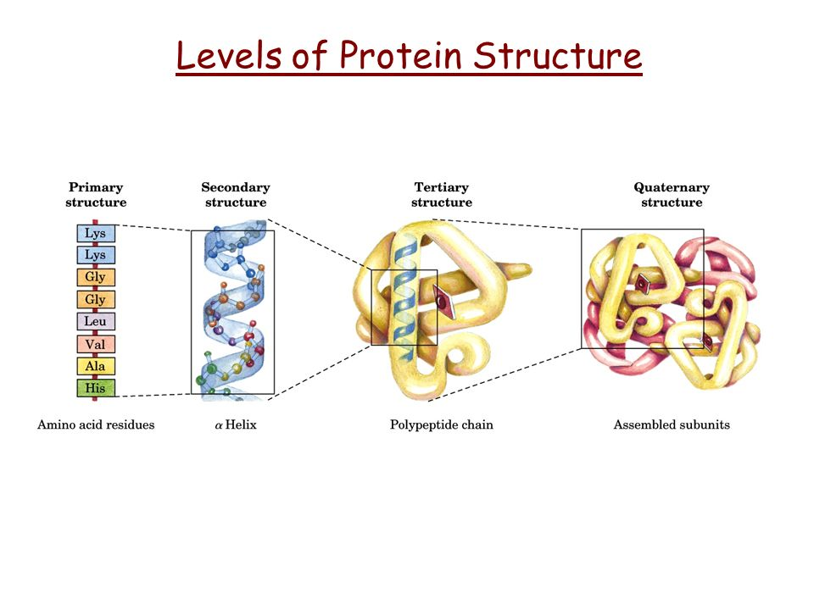**Mutations Visual Review**

What is the most important characteristic of a protein?

How is a proteins shape determined?

How does the structure of the protein affect its function? (think of amino acid R groups too)

What happens if the active site of an enzyme is the wrong shape?

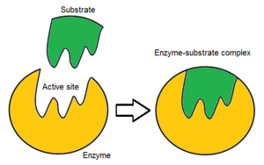

Define mutation-

What is a natural cause of mutations?

List some environmental causes of mutations.

**\*\*\*Mutations can be positive, negative or neutral.**

How are mutations connected to natural selection?

What process can cause a chromosomal mutation?

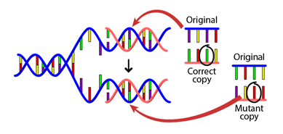

**Base Substitution**

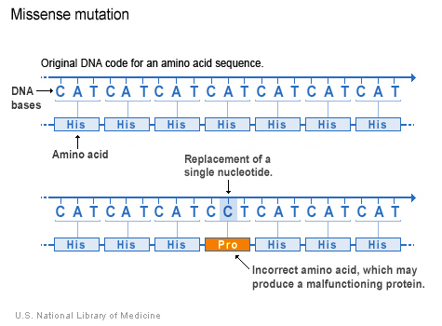

Name the two main categories of gene mutations.

What is a base substitution and what are it’s possible effects on protein synthesis? (base substitutions aka point mutations)

What is a frameshift mutation and what are it’s possible effects on protein synthesis?

Which is worse a base substitution or a frameshift mutation? Why?

**Frameshift**

**Specific Mutation Types**

Besides the fact that some mutation are positive or neutral, specifically, why can it be said that not all mutations are bad? (hint think codons and amino acids)

Define each of the following mutations:

Silent mutation-

Missense mutation-

Nonsense mutation-

What happens if there is a base substitution in an intron?

What happens if there is a base substitution or frameshift in the regulatory region of the gene?

What is a common UV mutation?

How can viruses cause mutations?

How can carcinogens (cigarette smoke, asbestos, radon gas), radiation (x-ray, cosmic, gamma) and chemical mutagens (nitrites, pollution) cause mutations?

Which two categories of genes can lead to cancer when mutated?

**Environmental Factors**

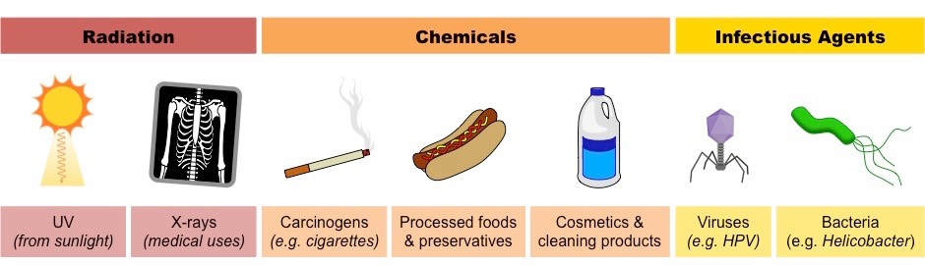

Why is “virus sex” considered a mutation?

Describe how “virus sex” occurs.

What are possible outcomes of “virus sex”?

Why are genetic recombination’s in bacteria considered mutations?

What happens during

Transformation-

Conjugation-

Transduction-

What is the most beneficial mutation bacteria can get during genetic recombination?

**“Viral Sex”**

**Mutations and Bacteria**