Claim, Evidence, Reasoning: The Case of Arthur’s Death
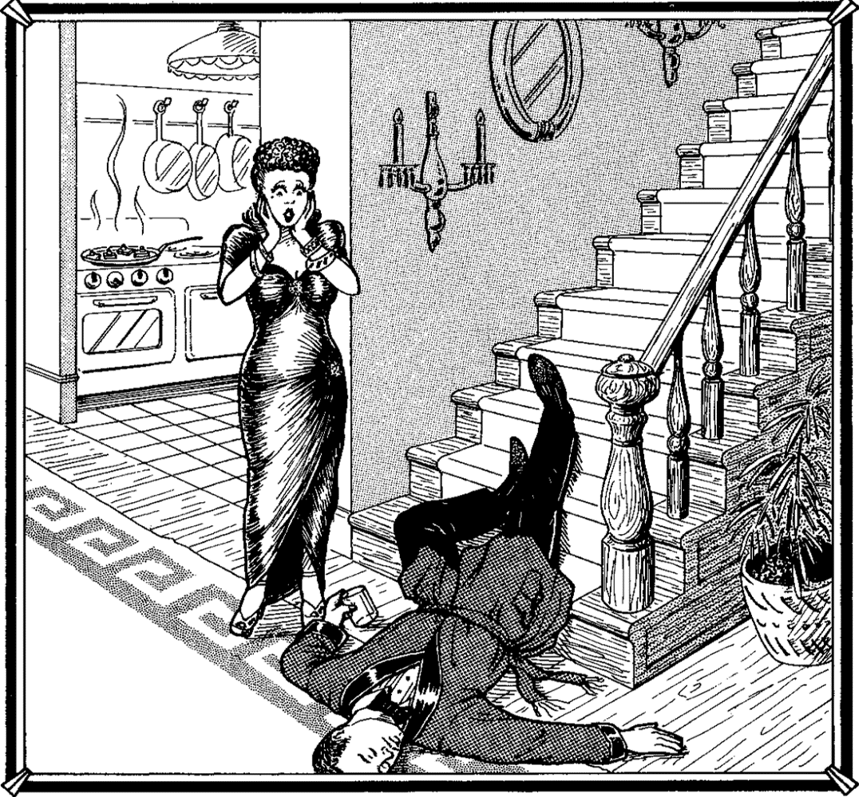
Based on the image above:
- Make a claim as to how Arthur died
- List the evidence that led you to making that claim
- Provide your reasoning by explaining how the evidence you listed supports your claim (why is the evidence relevant to your claim?)
Claim
Evidence
Reasoning
Claim, Evidence, Reasoning: The Case of Arthur’s Death
Based on the image above:
- Make a claim as to how Arthur died
- List the evidence that led you to making that claim
- Provide your reasoning by explaining how the evidence you listed supports your claim (why is the evidence relevant to your claim?)
Claim
Evidence
Reasoning

