**Neurons and Synaptic Signaling**

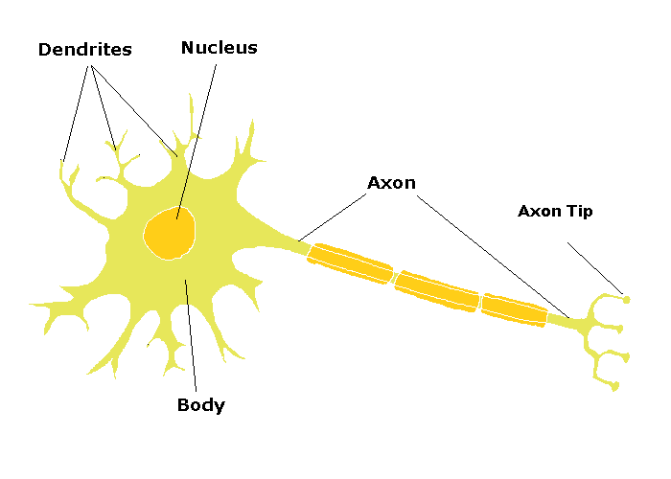 Neuron Basic Parts

Identify the function of:

Dendrites-

Cell body-

Axon-

Myelin Sheath-

Axon terminal-

Synapse-

Neurotransmitters-

Axon Terminal

Myelin Sheath

Synapse

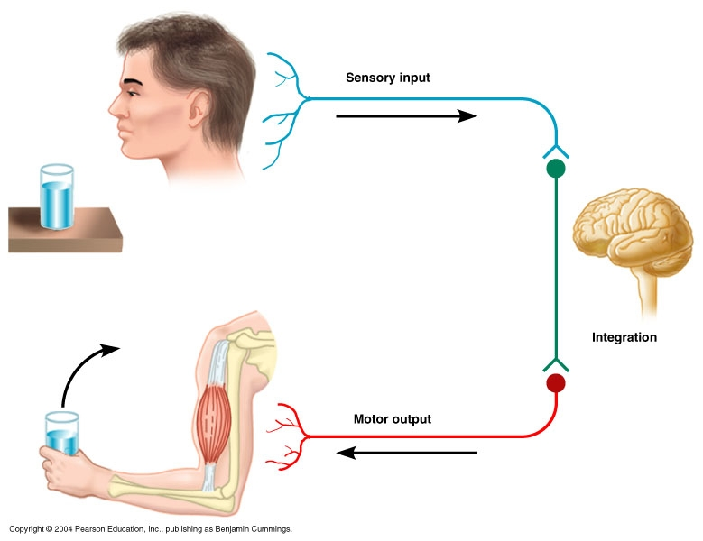 3 Main Types of Neurons

Which type of neurons gather information and send it to the brain?

Which type of neurons interpret information? Where do you find them?

Which type of neurons send information from the brain (or spinal cord)?

What happens when the electric signal gets to the end of an axon terminal?

What do we call the chemical message that floats across the synapse?

What type of local signaling is this?

It can be called synaptic signaling or ___________________

How does the neurotransmitter activate the dendrites of the next cell?

How do the neurotransmitters get removed from the synapse (synaptic cleft)? (there are two ways)

How can an inhibitor that binds to the receptor or enzyme that breaks down the neurotransmitter affect signaling?

Examples of neurotransmitters: acetylcholine (activates muscles), Serotonin, Dopamine…+40 identiied

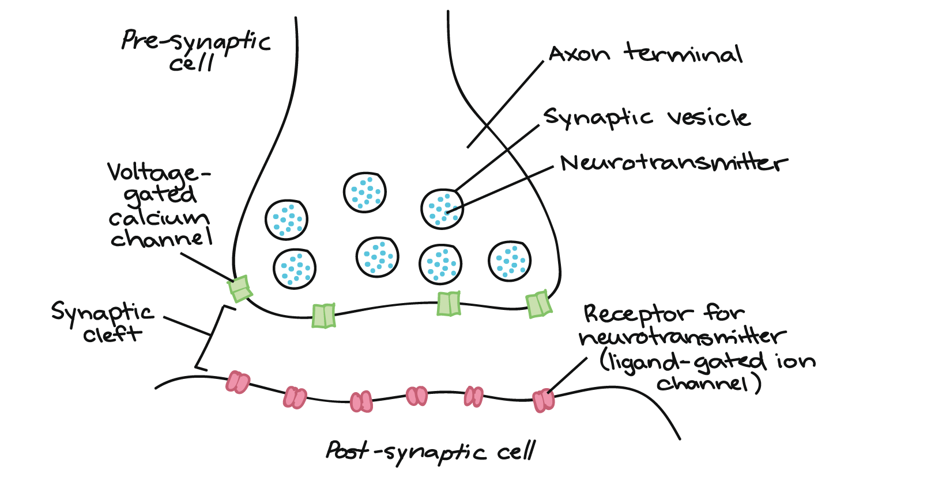 **Synapse (Synaptic Cleft)**

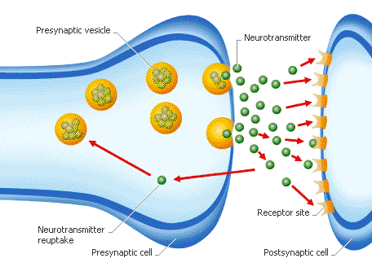

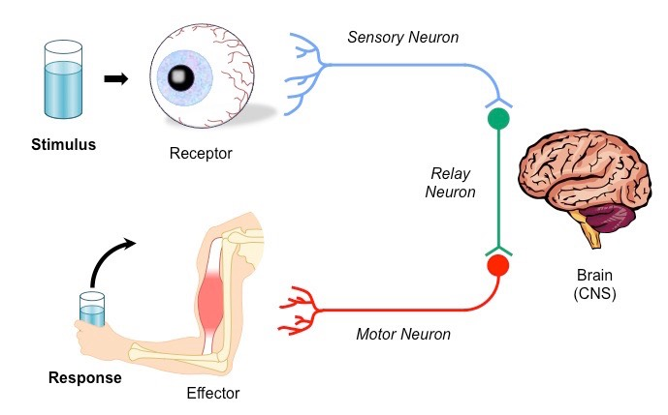 **Stimulus**

What is a stimulus?

What is a stimulus for

Eyes-

Hears-

Nose-

Mouth-

Skin-

What does a stimulus do at the dendrites?

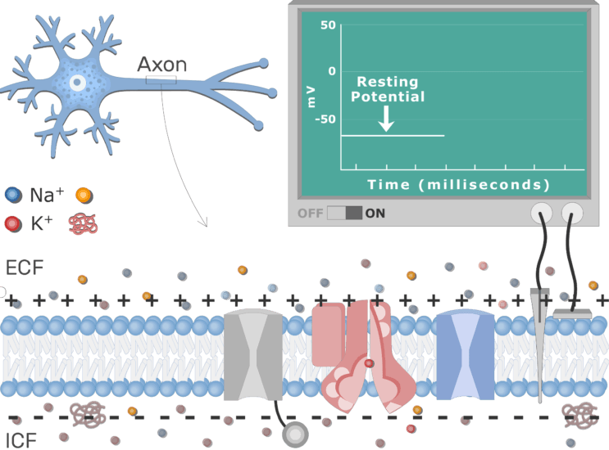 **Resting Potential**

What is meant by resting potential?

What is the charge outside and inside the cell during resting potential?

What is the approximate membrane potential charge?

What famous pump helps maintain resting potential?

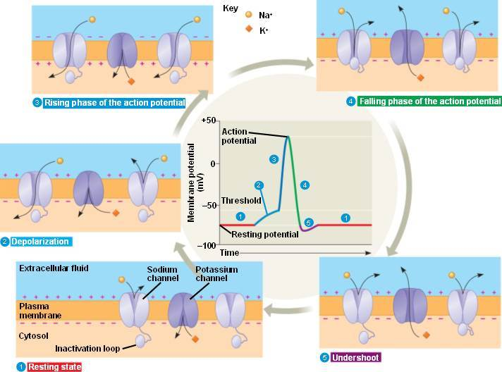 **Action Potential** **Action Potential at the synapse (synaptic cleft)**

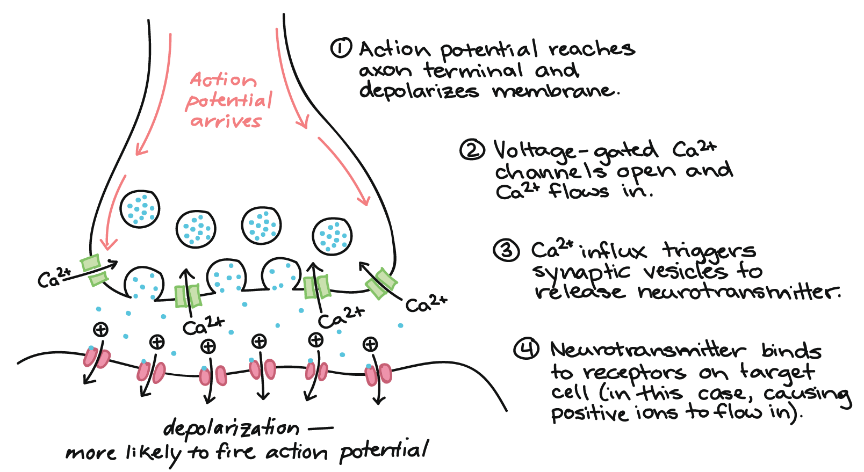

What is meant by action potential?

What is the charge outside and inside the cell during an action potential?

What is the approximate membrane potential charge when an action potential is reached?

What is the approximate membrane potential charge when an action potential is reached? _____________________

What two ions are involved in maintaining resting potential and action potential? ____________ and _____________

What happens when an action potential reaches an axon terminal?

What is the refractory period?



