**Nonmendelian Genetics Visual Review**

Probability

AaBbCC

What are the chances of the individual on the left producing a gamete that is AbC?

In a cross between the two individuals to the left, what is the probability that the offspring will be aaBBCc?

AaBbCC x aaBbcc

Incomplete Dominance

Complete Dominance

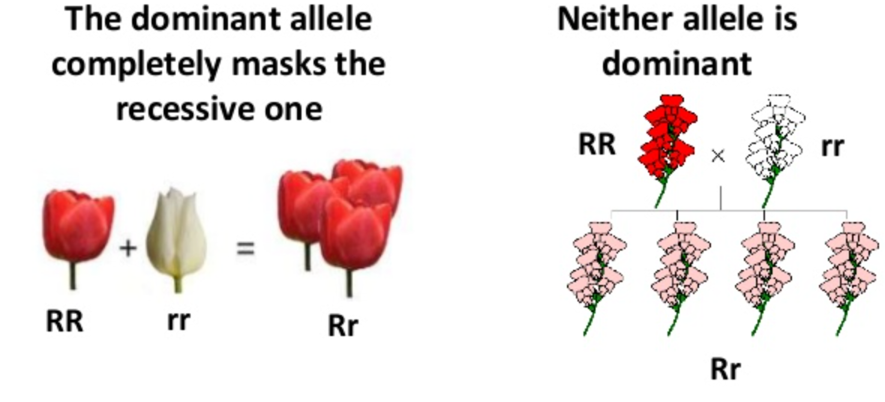

How can you tell if a trait follows complete dominance?

How can you tell if a trait follows incomplete dominance?

Complete a Punnett square for complete dominance.

Rr x Rr

Complete a Punnett square for incomplete dominance. Rr x Rr

How do the phenotype ratios differ?



How can you tell if a trait follows co-dominance?

Complete a Punnett Square for a human cross for blood type. AO x AB

What are the phenotypes of the offspring?

Complete Dominance

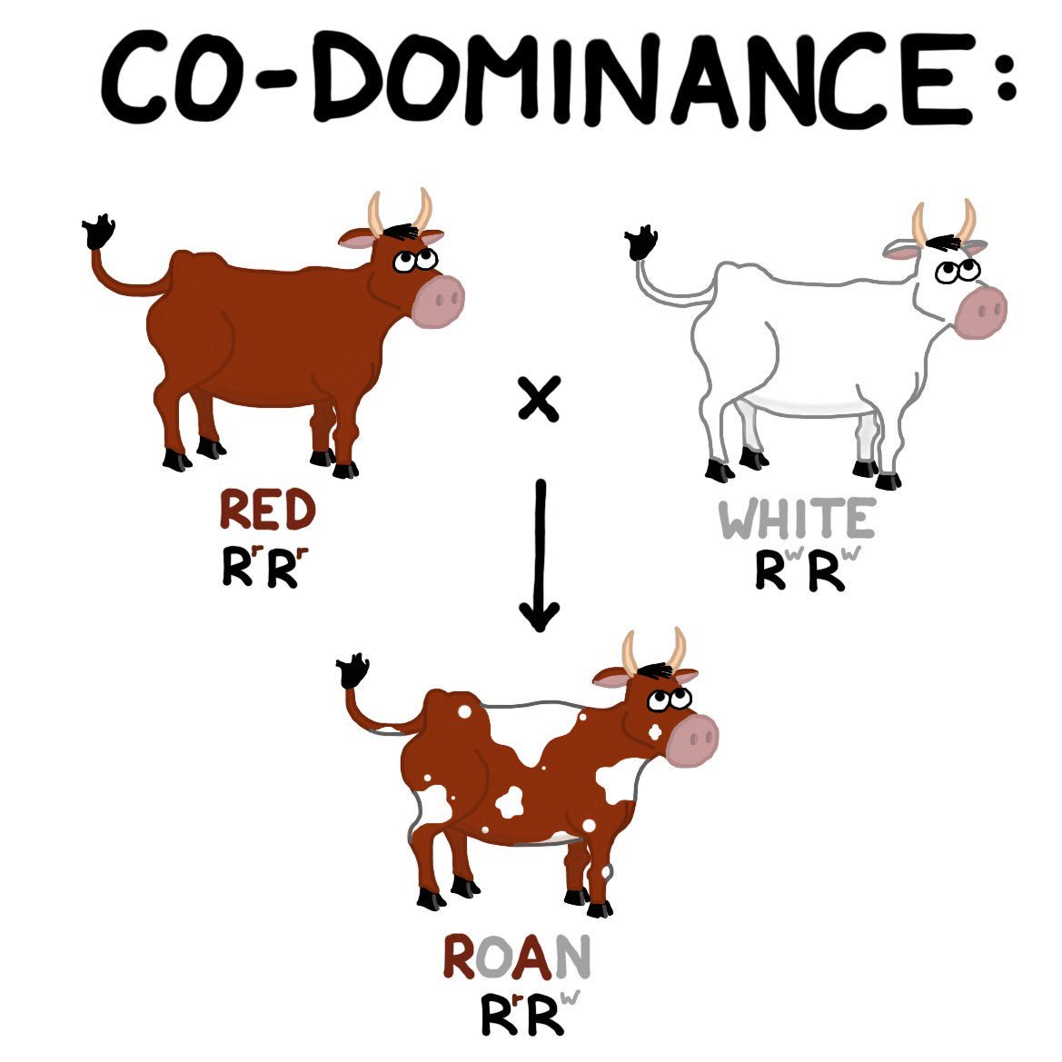

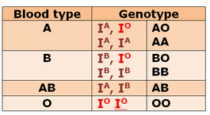



Polygenetic Inheritance

Epistasis

Pleiotropy

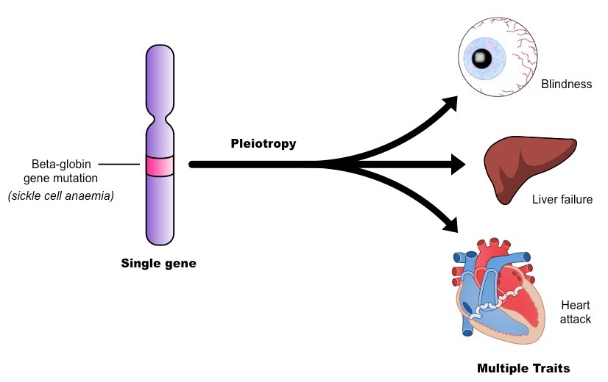

Expression of a phenotype is often the result of ________

plus ____________

What are some environmental factors that can affect the expression of genes?

Human example:

Plant example:

Butterfly example:

Reptile example:

Define Pleiotropy-

Define Epistasis-

What phenotype ratio can you expect if epistasis occurs? How is it different from the usual expected ratio?

Define Polygenetic inheritance-

How is this different from pleiotropy?

Environmental Effects on Gene Expression

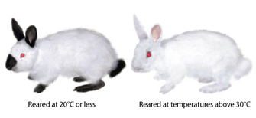

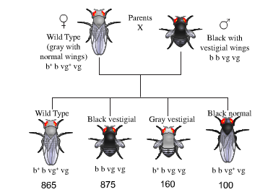**\*Linked genes and recombinant frequencies**

What are linked genes?

Among the offspring, identify the parental types and the recombinants in the image. How do you identify them?

Calculate the recombinant frequency.

Recombinant Frequency = # of recombinant offspring X 100

Total # of offspring

What is the key percent in recombinant frequency calculations and what does it mean?

What are the 4 major ways to tell genes are linked?

How can you tell if a trait (gene) is autosomal or sex linked?

What is a carrier?

In humans, if a male has an X-linked disorder XhY, who did he inherit the disorder from? Explain.

Can a man with an X-linked disorder pass it to his son? Explain.

Who do females inherit their X-linked disorders from?

List some X-linked disorders in humans.

Sex-linked Traits

Female genotypes and phenotypes

XHXH= Normal XHXh=Normal (Carrier) XhXh=disorder

Male genotypes and phenotypes

XHY=Normal XhY= disorder

Mitochondrial DNA (Also applies to chloroplast DNA)

Where is mitochondrial DNA found?

Who is it inherited from?

To be clear…

Who do females inherit their mitochondrial DNA from?

Who do males inherit their mitochondrial DNA from?

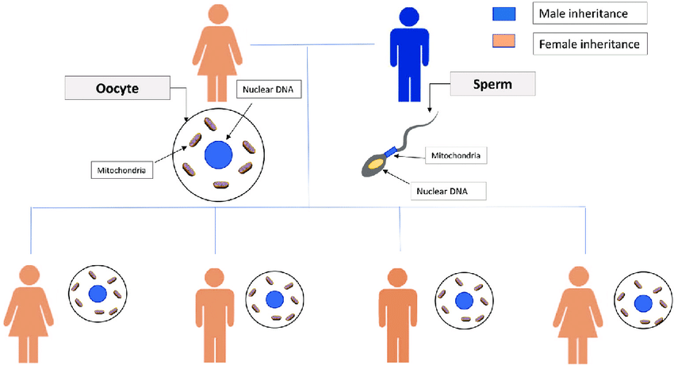

Mitochondrial DNA Disorder Pedigrees (Also applies to chloroplast DNA)

Who can an affected (disordered) female pass the disorder to?

Who can an affected (disordered) male pass the disorder to?

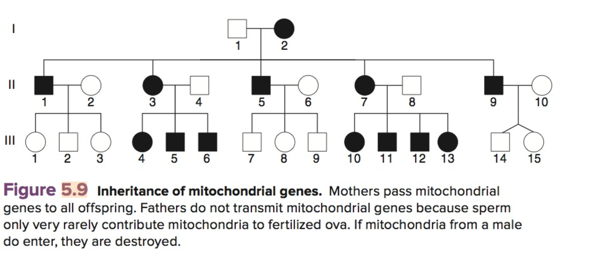

Explain the pedigree pattern for mitochondrial inheritance.

If couple 7 and 8 in generation II have another child, what are the % chances it has the disorder? Explain.

If individual 1, generation II remarries and has children with a woman who does not have the disorder. What are the % chances their 1st child has the disorder?

What if male 4, generation II remarries a woman with no disorder?