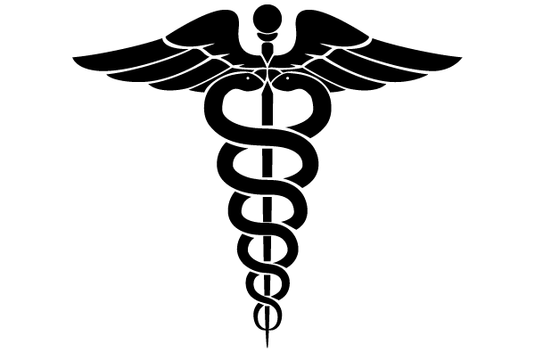
The Cure

Objectives
1) Explore chemical and physical properties, changes and reactions
2) Make observations. Collect, record and analyze data
3) Seek and weigh evidence to solve problems and draw inferences using scientific principles

Background
You are researching the cure for pancreatic cancer. During experimentation of different pharmaceutical powders on tumors grown in test tubes, your new lab assistant mislabeled the powders and one powder accidentally contaminated the sample of another powder. Luckily you caught this error, but the results of this accident were unexpected. The combined powders effectively killed the cancer cells! Now you need to figure out which samples they were, and retest to see if you get similar results.
Each pharmaceutical powder has different physical properties. They will react differently with other chemicals too. Some will not react at all with a substance at all, while others will produce obvious chemical reactions. First you will complete chemical and physical property tests on each sample. Then you will take the contaminated sample that contains two powders and tests its chemical and physical properties. Based upon your previous tests on the individual powders, you will need to determine which of the two powders were mixed together and are a cure for pancreatic cancer!!!

Materials
- goggles -pharmaceutical powders - eye droppers
- chemical-resistant gloves - iodine - candle
- magnifying glass - clothes pin - aluminum foil
- water - vinegar

***Safety***
Students must wear goggles during this experiment. Everyone should be careful while working with the flame. Long hair must be tied up. You should not wear clothing with baggy sleeves. Be sure to discard the heated material in the location your teacher indicates.

Procedures
Physical Property Test
1. Observe the color of each powder and record your observations in the data table.
2. Observe a few grains of each type of powder on a piece of black paper with a magnifying glass. Record your observations in your data table.
3. Take a small amount of each powder and feel it when it is dry. Record in your data table.
4. Take a pinch of each powder and add 3 drops of water to it. What does it feel like wet? Record your observations in the data table. Feel

Physical Properties Observations
Powder | Color | Magnifying Glass | Feeling when dry | Feeling when wet
1
2
3
4
5

Procedures
Note: If smelling the powder, do not inhale the smoke. Instead, use the wafting technique shown by
the teacher. Do not consume any of the powders.

Chemical Property Test
1. Iodine Test: Take a small pinch of each powder and place it into the tray. Add 3 drops of iodine to it. Record the results in the data table.
2. Vinegar Test: Take a small pinch of each powder and place it into the tray. Add 3 drops of vinegar to each powder. Record the results in the data table.
3. Flame Test: Take a small piece of aluminum, wrap the small foil over your thumb and tightly squeeze the foil over your thumb, to make a small pan. Use a clothespin as a handle for the pan. Add a pinch of the powder and place it in the pan. Heat the pan over the flame for 2-3 minutes and make observations. Be sure to discard pan with burnt powder in area designated by teacher. Be sure to use a clean piece of aluminum foil for each of the different powders.

Chemical Property Data Table Example
Powder | Vinegar | Iodine | Heat
1
2
3
4
5

Mystery Pharmaceutical Powder Mix Identification
Once you have completed the physical and chemical property test, then ask me for the mystery powder vile. Each vile contains 2 powders. You must identify what those powders are based upon the results of the previous test that you have run. GOOD LUCK! Use the space below to record your data.
In the space below, please write a paragraph explaining how you identified the mixed powders.
*Please be specific and explain how you identified the powders. (you can continue on a separate sheet of paper.)

