Numbers and Biomass Pyramids
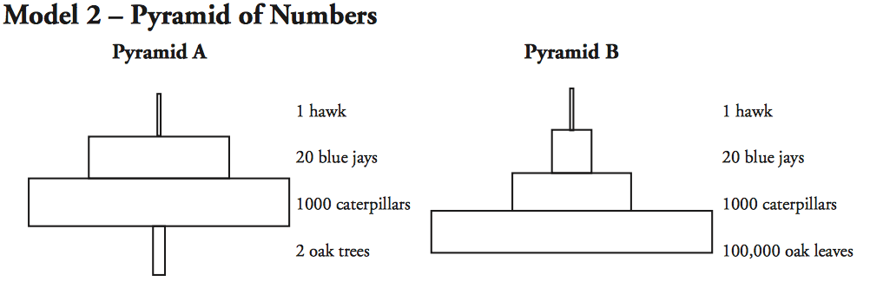

1. Compare and contrast the two pyramids in model 2. List at least two similarities and two differences.

2. Which of the two pyramids in model 2 gives a more accurate account of what occurs in this ecosystem? Why?

3. Why do you think the number of organisms decrease as you move up the pyramid? (hint: look at the energy pyramids on the first page

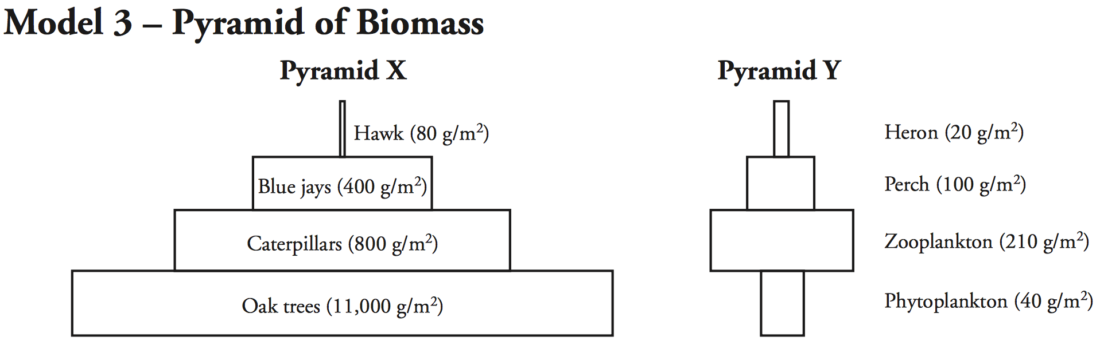

4. Biomass is measured as grams of dry mass within an area. What is the mass of the oak trees in Pyramid X of Model 3?

5. What is the mass of the phytoplankton in Pyramid Y of Model 3? Refer to Model 3.

6. Identify the trend in biomass as you move up the trophic levels in Pyramid X.

7. Is the trend in biomass in Pyramid X the same as seen in Pyramid Y? Explain your answer.

8. What type of organisms are missing from all of the trophic pyramids shown in Models 2-3?
9. Explain why a vegetarian diet is considered a more energy-efficient diet for humans than one based on beef, chicken or pork.

