Organelles and Endomembrane System

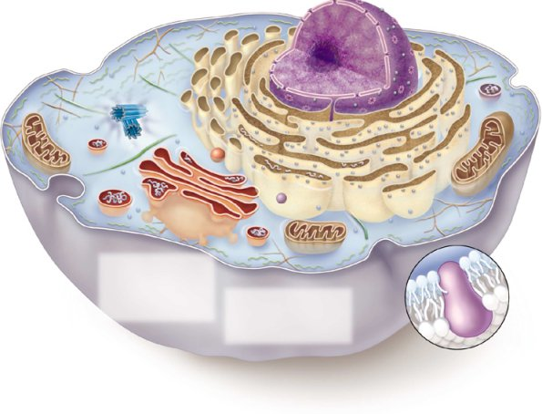

Is this a prokaryote or eukaryote? How can you tell?

Is this a plant or animal cell? How can you tell?

Next, label all of the following organelles on the image above. Then state the function of each.

Nucleus-

Ribosomes-

Difference between attached vs. free ribosome function?

Rough Endoplasmic Reticulum-

Golgi apparatus-

Cell Membrane-

Mitochondria-

Smooth Endoplasmic Reticulum-

Cytoskeleton-

Lysosomes-

Centrioles-

Vesicle (need to draw in)-

_____________________ ______________________

Identify the plant and animal cells.

What 3 things do plant cells have that animal cells do not?

What do animal cells have that plant cells do not?

On the plant cell label each of the following:

Cell Wall-

Plasmodesmata (draw them on, then

label)-

Chloroplast-

Large Central Vacuole-

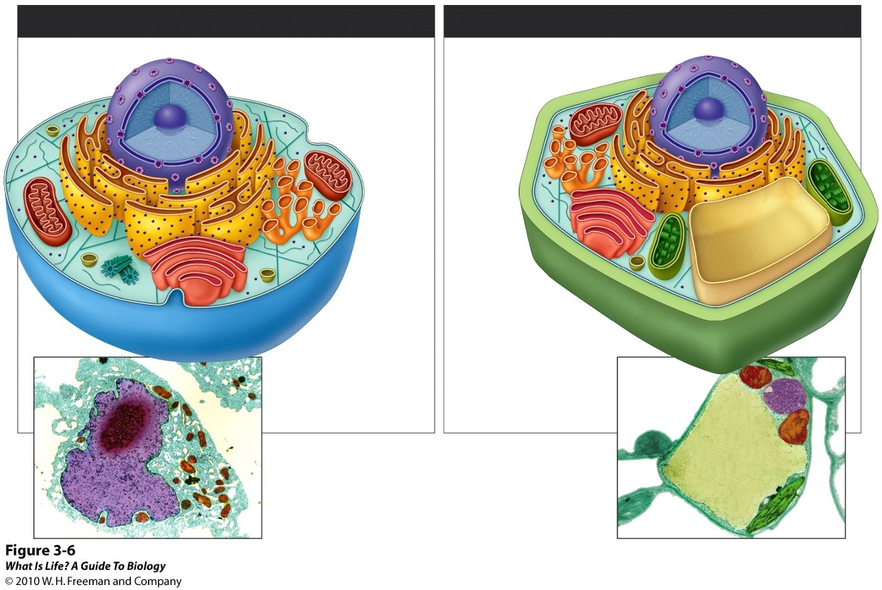

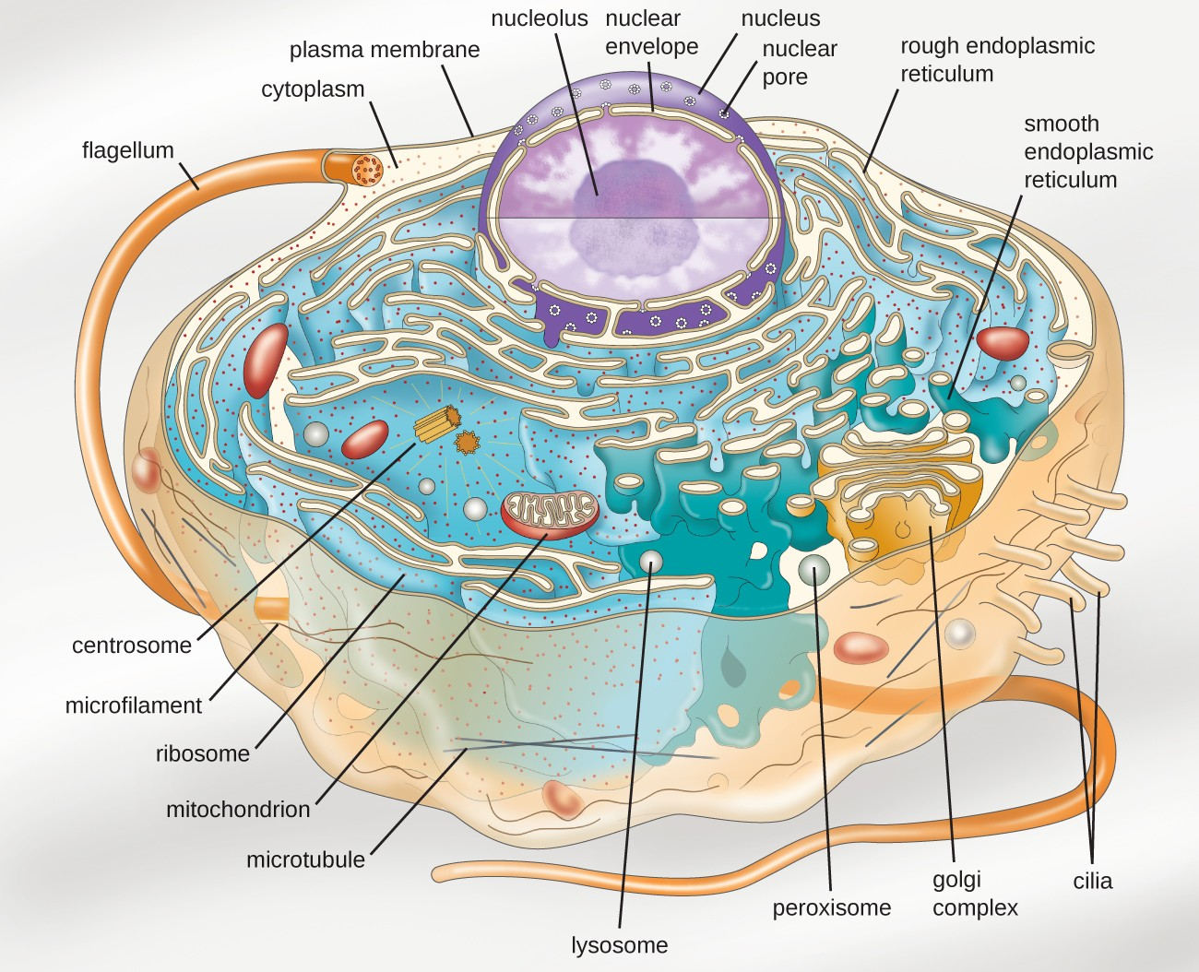

What are cilia? What are flagella?

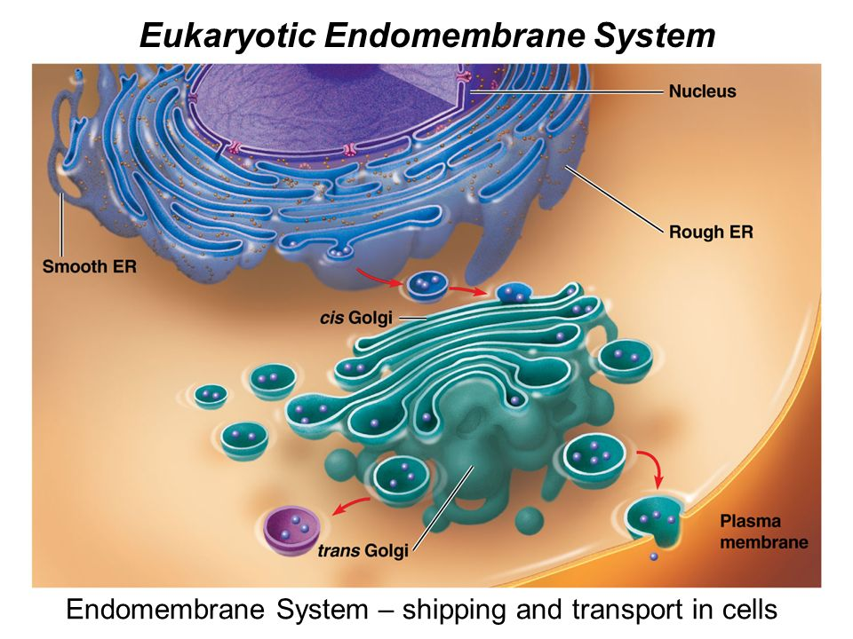

What is the purpose of the endomembrane system?

What are the 3 main organelles involved in the endomembrane system?

How do the proteins being shipped get to the correct location?

What kinds of proteins would be secreted from the cell or go to the cell membrane?

What kinds of proteins would remain in the cell?

***State the complete path of proteins __________________

Nucleus🡪 ____________ 🡪 ______________ 🡪_____________ 🡪______________

__________________

More Complex Endomembrane System pathway

What substances are coming from the smooth ER?

What types of enzymes are packaged into the lysosomes when they bud off from the golgi apparatus?

How do lysosomes help with digestion and cellular respiration?

Where will lysosomes send the broken down macromolecules?

