Name: ___________
Main Ideas Title: Oxidative Phosphorylation: ETC & Chemiosmosis Period: ___ Seat:__
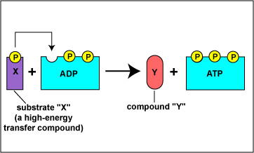
Types of Substrate level phosphorylation- using an enzyme to
Phosphorylation _______________________________________________
_______________________________________________

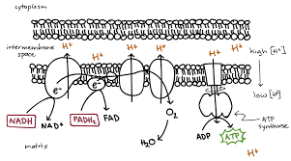

Oxidative phosphorylation-___________________ to draw electrons down an electron transport chain _______
______________________________________________
______________________________________________
______________________________________________

Which pathways of cellular respiration use substrate level
phosphorylation?

Anaerobic vs. Anaerobic respiration- generates ATP _____________________________ (very little ATP)
Aerobic Aerobic respiration- generates ATP only ___________________________________________
Yields nearly 10 times more ATP
Anaerobic Aerobic
Oxygen?
Occurs in?
Amount of Energy made?
Products?
What happens to glucose?

Oxidative 2 parts to this:
Phosphorylation 1)ETC: Series of redox reactions that use electron carrier proteins to slowly release the energy from NADH and FADH_{2…} Moves H⁺ out of matrix to intermembrane space
2)Chemiosmosis: Process that uses the movement of H+ through ATP synthase to phosphorylate ADPATP

ETC *Removes the electrons from NADH and FADH₂ passes them ___________________________
*Creates an H⁺ gradient by _______________________________________________________
_____________________________________________________________________________
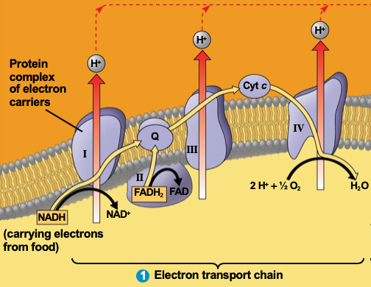

Chemiosmosis The H⁺ wants to move back into the mitochondrial matrix—_____________________________
Energy from movement is enough to __________________________________________

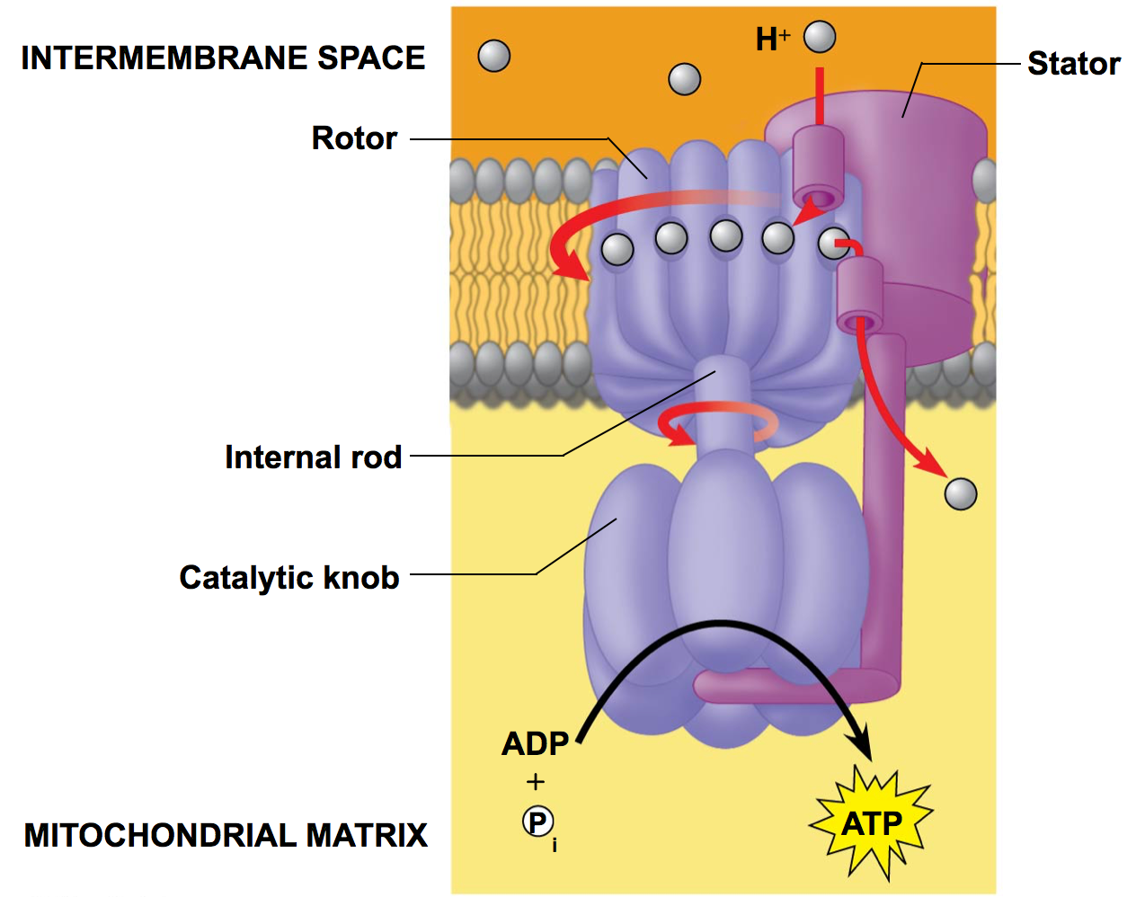

Carbohydrates (sugars) enter at…
Proteins (amino acids) enter at…
Lipids (glycerol) enter at…
Lipids (fatty acids) enter at…

Summary

