**Photosynthesis**

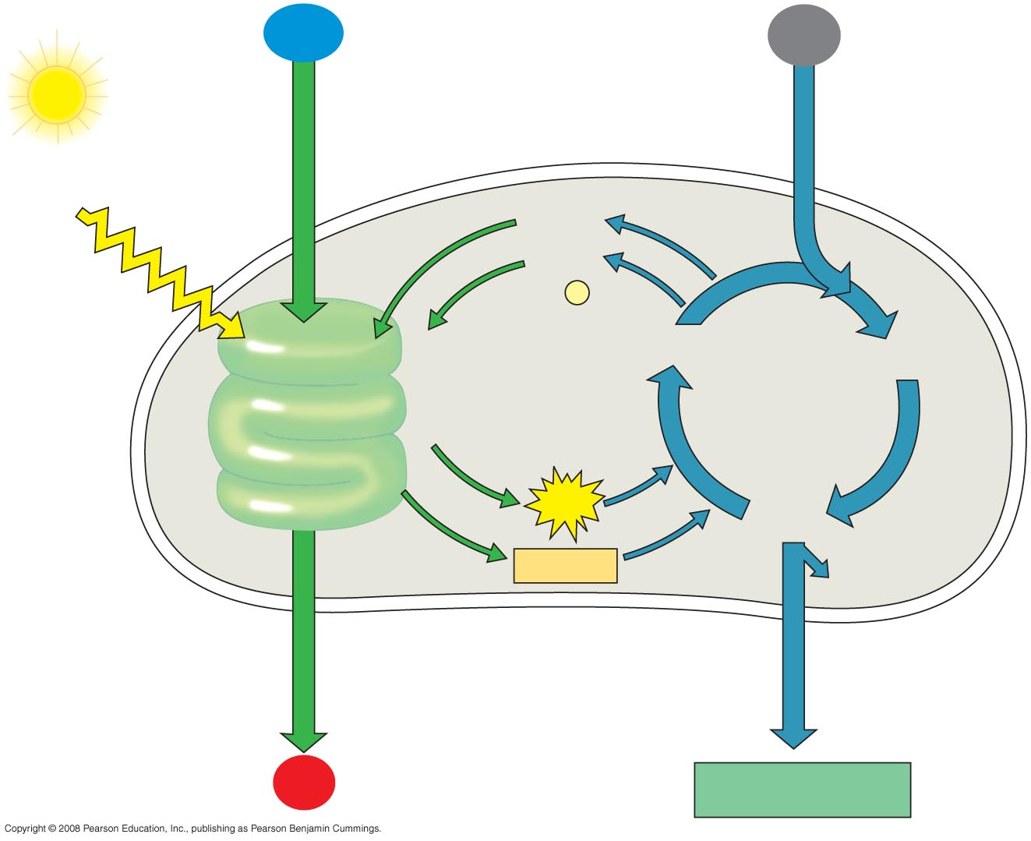

Write the word and chemical equation for photosynthesis.

Is this process anabolic or catabolic? Exergonic or endergonic?

Label the thylakoids and stroma. Identify and label all the missing information on the diagram

How can you tell the difference between the Light Dependent reaction and the Calvin Cycle (light independent)?

What molecules can you measure the amount/concentration of to determine the rate of photosynthesis?

What other molecules can glucose (G3P) be used to make?

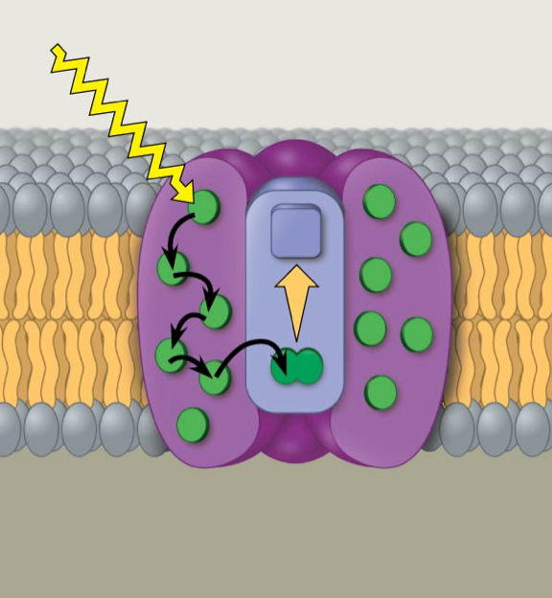

What is the image to the right?

Label the chlorophyll a’s, electron acceptor, and the pigments.

Explain what it does.

Which comes first photosystem I or photosystem II? What are their chlorophyll a’s called?

What is this graph showing us?

Use it to explain why plants are green.

Identify the wavelengths chlorophyll a absorbs best.

Identify the wavelengths chlorophyll b absorbs best.

Identify the wavelengths carotenoids absorbs best.

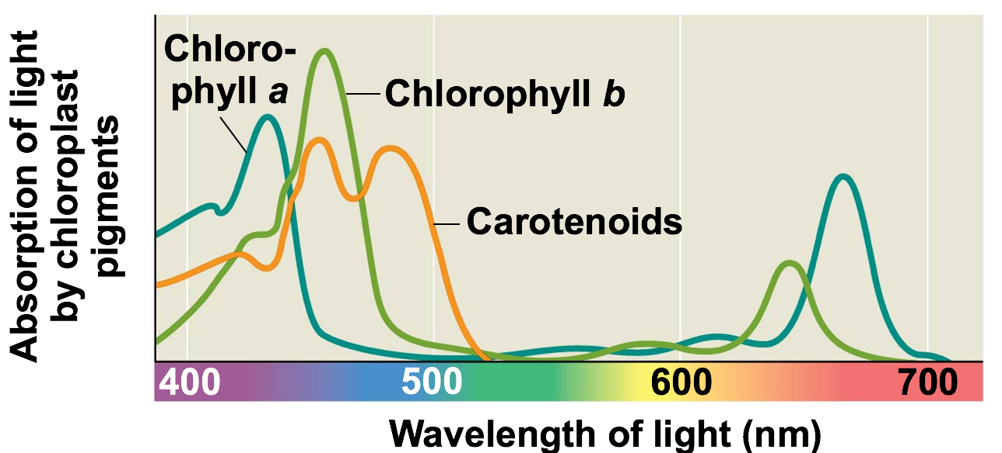

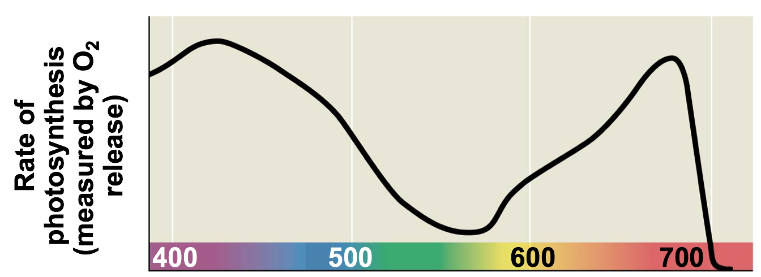

What is this graph showing us?

*Why is oxygen released a good indication of photosynthesis occurring?

How does it connect to the graph above?

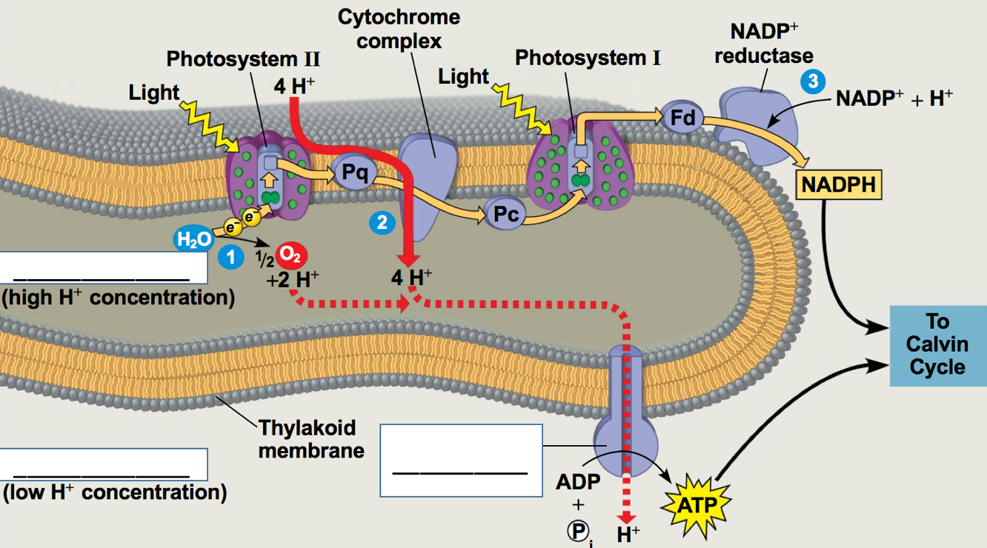

**Calvin Cycle (light independent):**

Purpose?

Where does the Calvin Cycle occur?

What are the 3 phases of the Calvin Cycle? What happens during each?

What is carbon fixation?

What is RuBP?

What is Rubisco (full name of Rubisco… RuBP oxygenase carboxylase)?

What happens to ATP and NADPH during the Calvin Cycle?

What is made by the end?

Use the image to explain the overall process of the Calvin Cycle.

How is photorespiration connected to the Calvin cycle? Explain what you know about photorespiration.

**Light Dependent Reaction (use the image above):**

Purpose?

Where do the light dependent reactions happen?

Use the image to explain the electron transport chain. *Why is water needed?

Use the image to explain chemiosmosis.

Use the image to explain how the electron transport chain and chemiosmosis are connected.

.

