Predator and Prey Lab

Name: ____________________

Period:_______ Seat: ________

Introduction:

The populations of various species in an ecosystem rise and fall depending on many different biotic and abiotic factors, one of those biotic factors is the predator/prey relationship. The number of predators depends on the number of prey and the number of prey depends on the number of predators. The two populations are closely linked, and a change in one can cause a change in the other. Lets take a look at wolves and moose in Yellowstone National Park.

Observation: The wolf and moose populations have changed in numbers since the wolves have been reintroduced.

Question: How does the number of predators affect the number of prey?

Hypothesis: _______________________________________________________________________________

_________________________________________________________________________________________

Materials: Population numbers tables, graph paper, ruler, red and blue colored pencils

|  |  |
| --- | --- |
| Date | Number of Wolves |
| 1960 | 20 |
| 1965 | 18 |
| 1970 | 10 |
| 1975 | 40 |
| 1980 | 50 |
| 1985 | 15 |
| 1990 | 12 |
| 1995 | 21 |
| 2000 | 14 |
| 2005 | 30 |
| 2010 | 25 |

Use blue for the moose and red for the wolves

Use this y-axis to graph wolf data

Use this y-axis to graph moose

Data:

**Change In Population Sizes**

Number of Individuals in Moose Population



Number of Individuals in Wolf Population

60

55

50

45

40

35

30

25

20

15

10

5

3000

2800

2600

2400

2200

2000

1800

1600

1400

1200

1000

800

600

400

200

|  |  |
| --- | --- |
| Date | Number of Moose |
| 1960 | 600 |
| 1965 | 750 |
| 1970 | 1600 |
| 1975 | 1250 |
| 1980 | 900 |
| 1985 | 1300 |
| 1990 | 1500 |
| 1995 | 2500 |
| 2000 | 500 |
| 2005 | 800 |
| 2010 | 450 |

[](http://www.clker.com/clipart-11651.html)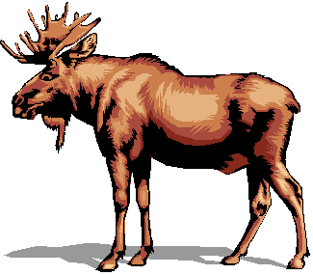

‘60 ’65 ’70 ’75 ’80 ’85 ’90 ’95 ’00 ’05 ’10

Date

Analysis/Conclusion:

1. Look at your graph, how are the wolf and moose populations related to each other?

2. How does the size of the moose population affect the wolf population survival?

3. How does the size of the wolf population affect the moose population survival?

4. What would the result be if another predator such as a lynx (a bobcat type predator) were added to the community?

5. In 2000, Yellowstone had one of its coldest winters on record and very little plants were available

a. What happened to the moose population? Why?

b. How did this affect the wolves?

6. List some other examples of predator-prey relationships.

7. How does this activity relate to human populations in the world?