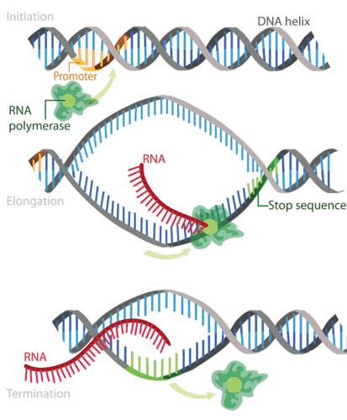
Prokaryote Transcription
Termination Sequence

Prokaryote Transcription
Termination Sequence

