Name: ___________
Main Ideas Title: Pyruvate Oxidation and Krebs Cycle (Citric acid)Period: ___ Seat:__

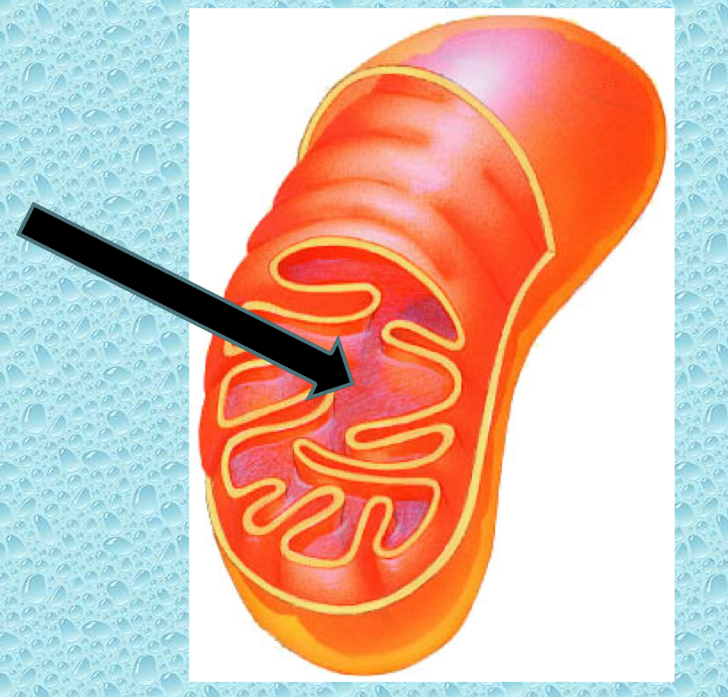

Where do they _____________________________________
happen? in the mitochondrial matrix

Pyruvate Converts Pyruvate (3C) to ____________________________________________
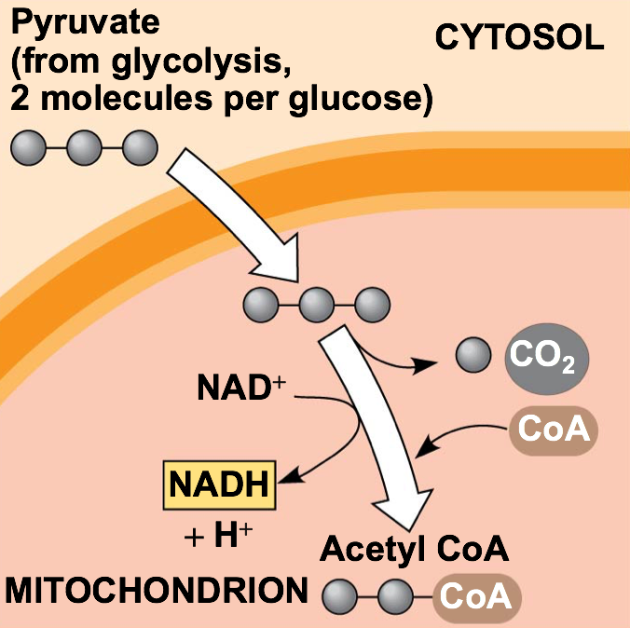
Oxidation Each pyruvate produces:
*________________
*________________
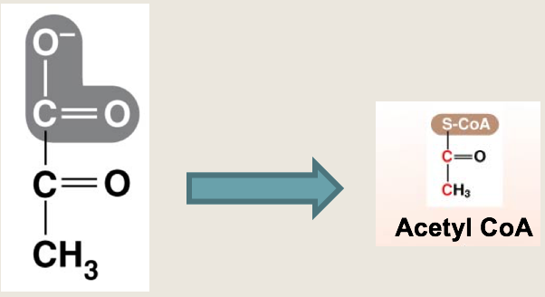
*________________
*Acetyl CoA goes to stage 3

Krebs Cycle 8 step cycle that ________________________________________________ out of acetyl CoA
(Citric Acid) and puts it into _____________________________
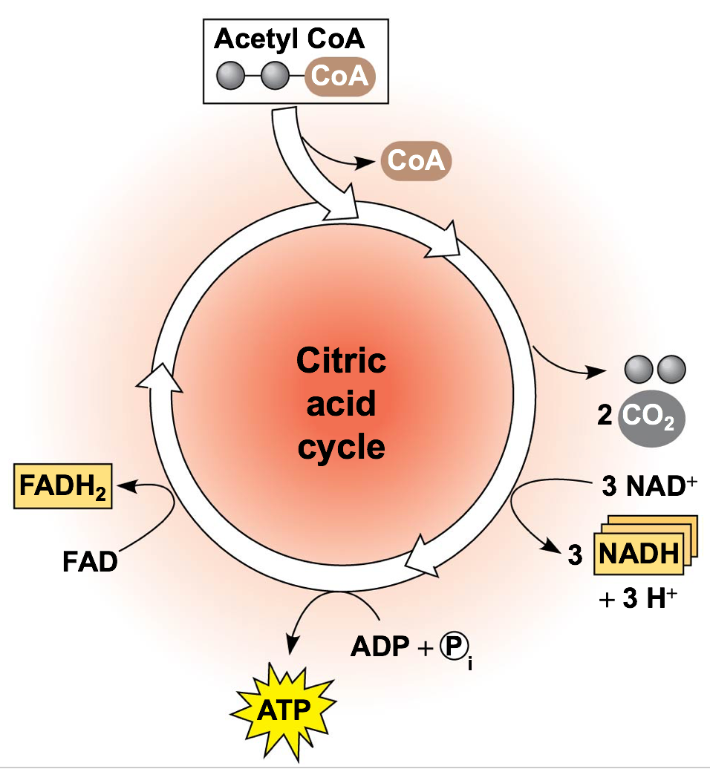
Each acetyl CoA produces:
*_________________
*_________________
*_________________
*_________________

Key Points 1st step breaks off the acetyl group of acetyl CoA and ___________________________________
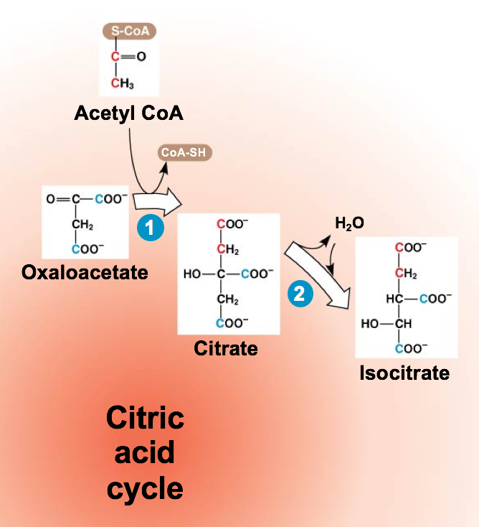
_________________________________

Next 7 steps include several _____________________ that produce 3 NADH, 1 FADH₂ and
________________________________________________________ (for each pyruvate)
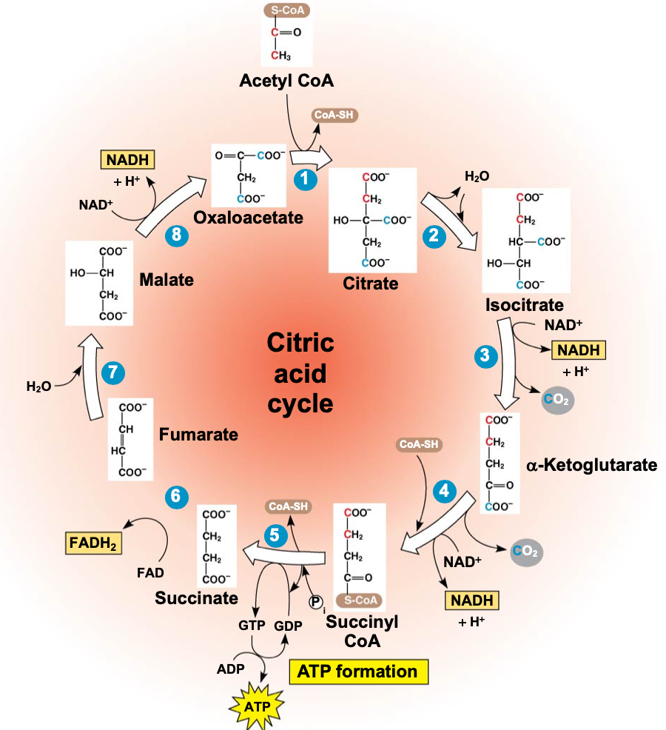

ATP Check Point : ATP Grand Total to this Point
How many ATP have we made (including glycolysis)? _________________

Where did all the energy go? ______________________________________

Summary

