Quarter 3 Midterm Review

Name: __________________

Period: _______ Seat: ______

Scientific Method

1. Define: Control- Group that is not tested so that you can ____________________

Manipulated Variable-

Responding Variable-

2. List the steps of the scientific method in order: 1) Observation 2) Question 3)_______________ 4)_______________

5)____________________ 6)___________________

3. What is the difference between a hypothesis and a theory?

4. How do scientists compensate for unavoidable experimental error?

5. a. Which type of graph is best to use for showing change over time? __________________

b. Which graph is best used for comparisons? _________________

Macromolecules

1. ___________ is the most common atom that is the building block of life because it can form ______ chemical bonds.

2. Where do living things get their matter (atoms/molecules/macromolecules) from?

Living things get their matter from ____________________________

3. a. What is the law of conservation of matter?

Matter cannot be created or destroyed, only ________________________

b. What does our body do with macromolecules?

1. Complete the chart about macromolecules.

|  |  |  |
| --- | --- | --- |
| Macromolecule | Monomer | Function |
| Carbohydrates |  |  |
|  |  |  |
|  |  |  |
|  |  |  |

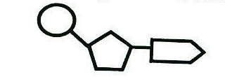

1. Identify this monomer. _____________________ What are its 3 parts?

6. Where do you get your monomers from, to build your macromolecules?

**Cells**

1. What are the two main types of cells? _______________ and ___________________

2. What does “Pro no, Eu do” mean?

Pro no, Eu do means __________________________________________________________________

______________________________________________________________________________________.

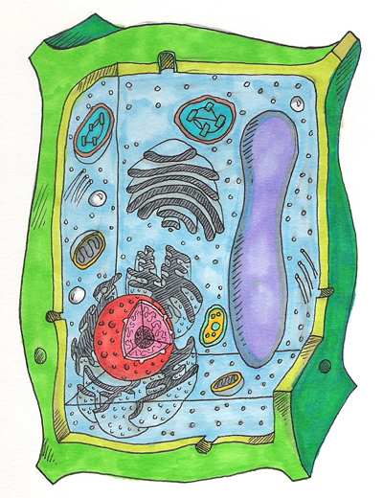3 Which are prokaryotes and which are eukaryotes below?

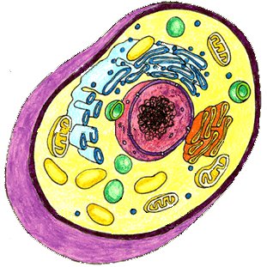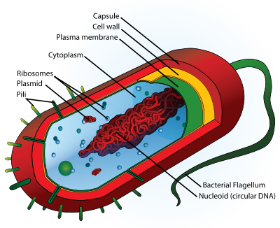

Animal Cell Bacteria Cell Plant Cell

___________ ____________­­­­___ ______________

4. What 4 things do all cells have no matter which type of cell they are?

All cells have

5. Draw a picture of the cell membrane and label its parts.

Cell Membrane:

6. What does the cell membrane do?

7. a. What 3 things do plant cells have that animal cells do not?

Plant cells have

b. Why do plants have these three things but not animal cells?

Plant cells have these three things because

8. Describe what organelles are in your own words?

Organelles are__________________________________________________________________

9. What organelle controls the cells activities?________________

10. What organelle synthesizes proteins? ___________________

11. What is the organelle that packages and secretes proteins out of the cell? ___________________

12. What organelle in both plants and animals breaks down glucose to provide energy for the cell?

________________

13. What macromolecule is assembled, modified and secreted by the rough endoplasmic reticulum?

______________

14. What macromolecule is assembled and secreted by the smooth endoplasmic reticulum?

___________________

15. What organelle uses carbon dioxide and sunlight to synthesize sugar and store energy?

___________________

16. What structure found only in plant cells provides support and protection? ___________________

17. What is the function of the cytoskeleton?

**Cell Membrane transport**

1. What are 3 types of transport? (not including endo or exocytosis)

2. What is diffusion? Do molecules move from low to high or high to low concentrations?

3. a. How is facilitated diffusion different? b. How is active transport unique?

4. What type of transport is Osmosis? Explain why you get old people fingers when you stay in the pool too long.

**DNA and Protein synthesis**

1. DNA is a set of instructions to make and maintain a living thing. It contains a secret code that is really instructions for assembling ____________________ which determine our _______________________

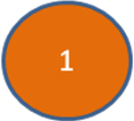

2. The monomer unit to the right which connects together to other similar units

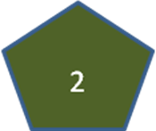to make DNA is called a __________________



***3. Label its three parts.***

4. Name the 4 bases found in DNA?

1. _____________ 2. _______________ 3. _____________ 4. _____________

5. What types of bonds hold together DNA?

6. DNA replication results in two DNA molecules

a. each with two new strands c. one with two new strands and the other with two original strands

b. each with two original strands d. each with one new strand and one original strand

7. When does DNA replication (making a copy) occur?

8. Complete the following chart on DNA and RNA:

|  |  |  |
| --- | --- | --- |
|  | DNA | RNA |
| Type of Sugar |  |  |
| Bases |  |  |
| Number or Strands |  |  |
| In what part of the cell is it found? |  |  |

9. Protein synthesis can be summarized as __________ _________ __________ (3 points)

10 Fill in the blanks with the correct organelles: Protein synthesis starts in the ________________, then moves into the ____________________ and ends on a ______________________.

11. In protein synthesis DNA mRNA is called _______________

It takes place in the _______________________

12. Reading the codons in the mRNA to put together amino acids to make a protein is called ___________________.

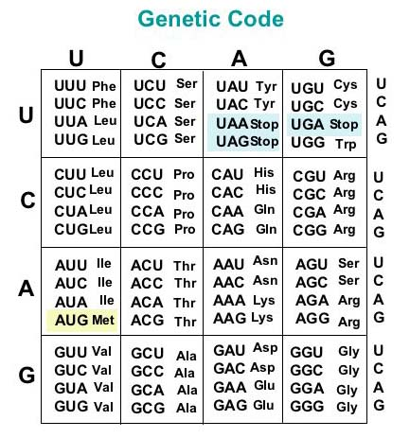 It takes place on a ______________________

13. Write the complimentary DNA strand ACCATAGATACT

14. a. Transcribe this DNA: GGACTAGAATCCATC

b. How many codons are there? ______

15. Translate this mRNA: AUGCAGAUCACCGGAUAGUAA

16. Make the protein this DNA codes for: TACCCATGATAGGACCAGATT

17. There are 20 different amino acids you can combine to make proteins. You can make different proteins by changing the ________________________ and ________________________ of the amino acids.

18. Name the two kinds of mutations and state which is worse.

19. Not all mutations change the protein. Why?

**Chromosomes, Mitosis and Meiosis**

1. A chromosome is made of _________________ wrapped tightly around __________________________.

2. Somatic cells = ____________________ = __________________________

Gametes = _______________________ = __________________________

3. How many chromosomes does a human gamete contain? ______

How many chromosomes does a human body (somatic) cell contain? ______

4. What two chromosomes do you need to be female? ________

What two chromosomes do you need to be male? ________

5. A fish has 94 chromosomes in its body cells. What is its haploid number? ______ What is its diploid number? ____

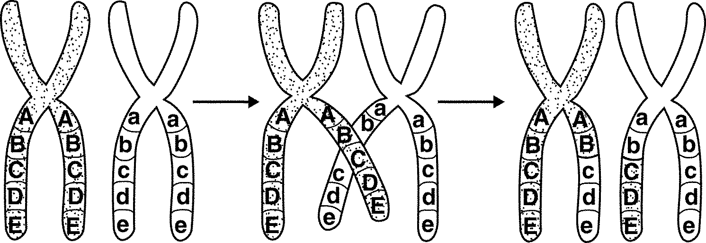

6. When does chromosome (DNA) replication occur?

7. What is crossing-over? During which phase does it occur?

8. When sperm and egg come together they form a _________

9. Math…

But first a. Put a box around the sex chromosomes and a big circle around all the autosomes

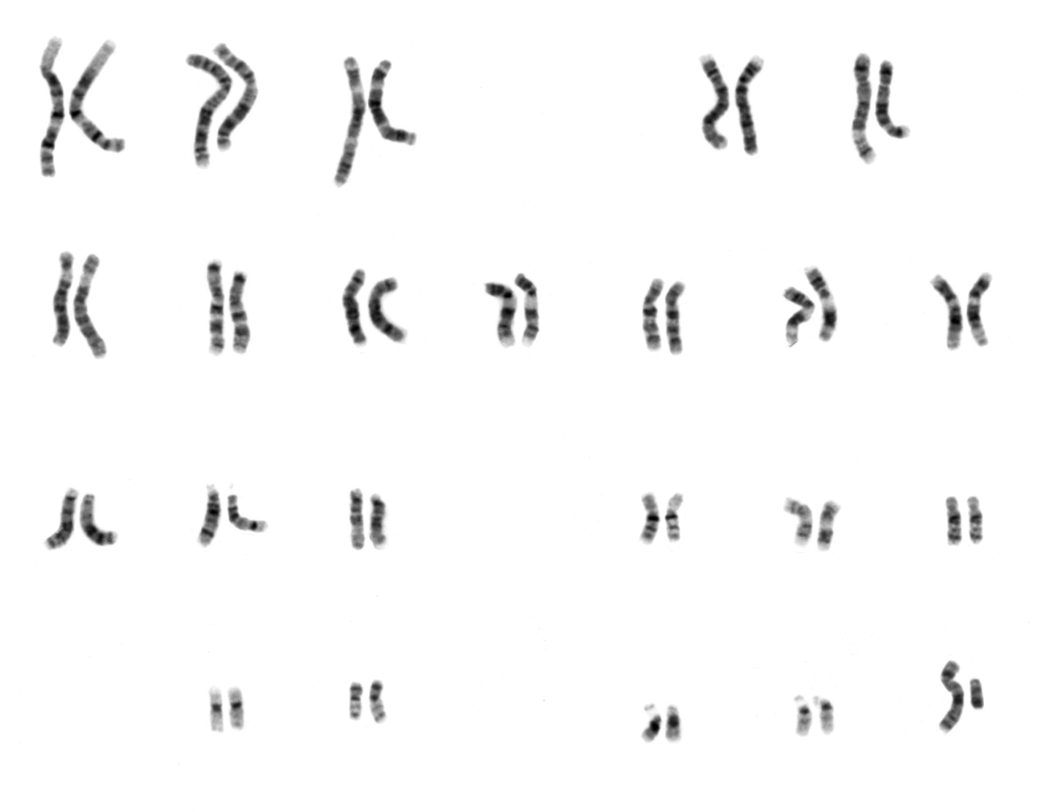

b. How many chromosomes do humans have total in each cell?

c. How many pairs?

d. How many are sex chromosomes?

e. How many are autosomes?

e. Complete the drawing using the math from b-e. Remember the number have to add up.

Total: _____

___ autosomes

+

___ sex chromosomes

Total: _____

___ autosomes

+

___ sex chromosomes

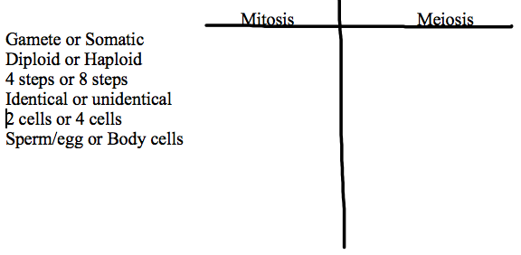 Egg Sperm

Total: __46___

___ autosomes

+

___ sex chromosomes

**10.**

Zygote

Zygote

**Genetics**

1. What does heterozygous mean?

What does homozygous mean?

2. What is the law of segregation?

3. What is the law of independent assortment?

4. In flowers, blue flower petals are dominant to red flower petals.

What are the possible phenotypes for the following flowers with these genotypes?

BB _______________________Bb _______________________bb _______________________

5. What is the phenotype of a heterozygous person if F is freckles and f is no freckles?

6. In humans, big ears are dominant to small ears. B=________________ b=________________

What are the genotypes for a person with big ears? _____,_____

What is the genotype for a person with small ears? ______

7. In dogs, short hair (H) is dominant to long hair (h). If a heterozygous short hair dog is crossed with a long hair dog, what percentage of the offspring will have long hair?

8. Name the two kinds of mutations and state which is worse.

9. Not all mutations change the protein. Why?

**Genetic Engineering**

1. Define genetic engineering-

2. What is one pro and one con for cloning?

3. What is one pro and one con for designer babies?

4. How is CRISPR changing genetic engineering?

5. What do you know about GMO’s?

6. What is one good thing about stem cell research and what is one bad thing about stem cell research?

**Human Heredity**

1. Draw a picture of a haploid cell with 5 chromosomes:

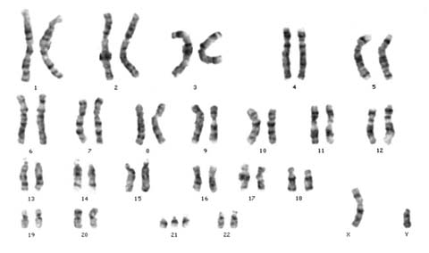 Draw a picture of a diploid cell with 6 chromosomes:

2. a. What is a homologous pair of chromosomes? Draw a picture

3. What percent of your DNA comes from each parent? _________________

4. A picture, like the one seen to the right, that shows a persons 46 chromosomes arranged from longest to shortest is called a ___________________________________

|  |  |
| --- | --- |
|  |  |
|  |  |

5. In humans, the Cystic Fibrosis allele (a) is recessive to the normal non-Cystic

Fibrosis allele (A) . Cross a heterozygous female with a heterozygous male.

What are the chances their first child is born with Cystic Fibrosis?

6. A child is born heterozygous for Black hair (Bb). Black hair allele (B) is dominant to the

blonde hair allele (b). List three possible genotype combinations his parents may have.

Mom Dad

7. a. What makes an X-linked disorder different from other types of disorders?

b. Name 3 X-linked disorders: ____________________,_____________________,___________________

8. Determine if the following couple will have sons and daughters who have Hemophilia.

H=Normal h=hemopilia *******Be carful with this one*******

|  |  |
| --- | --- |
|  |  |
|  |  |

a. Parent genotypes: XHXh x XhY

Parent phenotypes: ____________ and ______________

How many daughters have the disorder? _____

How many daughters are carriers? _____

How many sons have the disorder? _____

9. a. In order to have a son, a man must give a sperm containing 22 autosomes and a ____ chromosome=23 total

b. What are the chances of having a boy or girl. **Explain**.

**Ecology**

1. List the Levels of Organization from smallest to largest.

|  |  |
| --- | --- |
| Level of Organization | Definition/Example |
| Species |  |
|  |  |
|  |  |
|  |  |
|  |  |
|  |  |

2. How is a community different from a population and ecosystem?

3. What is the difference between autotrophs and heterotrophs? Give an example of each.

4. Complete the following chart

|  |  |  |
| --- | --- | --- |
| **Type of organism** | **What do they eat to obtain energy?** | **Give an example of an organism that gets its energy this way.** |
| Producer/Autotroph |  |  |
| Herbivore |  |  |
| Carnivore |  |  |
| Omnivore |  |  |
| Detritivore |  |  |
| Decomposer |  |  |

5. a. What is the law of conservation of energy? Energy can’t be ________________ or ________________ only

_________________________.

b. What happens to energy as it is passed along in a food chain?

6. Energy moves through an ecosystem in (2pts) a. two directions b. a cycle c. one direction d. all directions

**Use the Ecology Pyramid below to the right answer questions 7-10.**

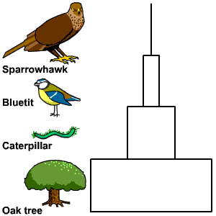7.Label next to the pyramid the producer, primary consumer, secondary consumer and tertiary consumer. Create a food chain from the organisms in the energy pyramid.

8. Each level in the food chain is called a ________________ level.

9. What level has the greatest amount of available energy? ____________

Why?

10. How much energy is transferred from one level to the next? ______

What happens to the rest (90%) of the energy?

11. What would happen to the other organisms if the autotrophs were to die?

Explain your answer. (3 things!)

12. a. What is the law of conservation of matter? Matter can’t be created or _______________ only _________________.

b. What happens to matter in an ecosystem? It gets _________________!!!

c. What do decomposers do in connection with matter?

Decomposers are super important to matter cycles because

13. Study the carbon cycle:

Name 4 things that release CO2 into the atmosphere.

Respiratioin, _____________________, ______________________,_______________________

Name 1 major thing that takes CO2  out of the atmosphere.

__________________________

14. Study your nitrogen cycle: What is nitrogen fixation? What types of organisms do it? What types of organisms benefit most from it?

**Photosynthesis**

1. In what types of cells does photosynthesis occur? Inside which organelle?

2. Write out the formula for photosynthesis

Word form: _______________+ _______________ __________________+__________________

Chemical from: _______________+ _______________ __________________+__________________

3. How does photosynthesis demonstrate the law of conservation of matter? Be specific!

4. What is the goal/point of photosynthesis? The goal/point is to make _______________________

5. Identify the pathway energy takes in photosynthesis. How does this demonstrate the law of conservation of energy?

6. Why is photosynthesis important to the carbon cycle?

**Cellular Respiration (aerobic respiration= in the presence of _______________)**

1. In what types of cells does cellular respiration occur? Inside which organelle?

2. What is the formula for cellular respiration?

Word form: _____________+ _______________ __________________+__________________+ _____________

Chemical from: _____________+ ______________ ________________+_________________+_______________

3. What is the goal/point of cellular respiration? The goal/point is to make _______________________

4. How are photosynthesis, cellular respiration and the carbon cycle all connected?

**Survival and Interdependence**

1. What four factors affect population size? Births, immigration, ________________ and _________________

2. Name the two types of growth and sketch a graph for each one. Which type occurs in nature?

 1) ______________ 2) __________________

3. a. What is carrying capacity?

b. In what type of growth do you see it? ________________________________

4. What are the three biggest (the big 3) factors to affect carrying capacity?

1) ____________________ 2) ____________________ 3) ____________________

5. a. What is biodiversity?

b. How do humans use it? 1) ____________________ 2) ____________________ 3) ____________________

6. What are the 4 ways humans threaten biodiversity?

1) ____________________ 2) ____________________ 3) ____________________ 4)_____________________

7. Name and describe 4 (we learned more) types of community relationships.

8. Define symbiosis-

Mutualism (M) or Parasitism (P)

Clown fish lives in and cleans sea anemone. Stinging tentacles keep larger fish away from clown fish.

Ants live on Acacia tree and use it for food. The ants prevent other insect herbivores from eating the plant. _____

Flea lives on dog and feeds on dogs blood.

________

Bee lands on flowers and get nectar for food. Flower pollen is transferred on by bees. _____

9. Define competition and predation.