Main Ideas Title: Cell Communication; Receptors and Transduction Pathways

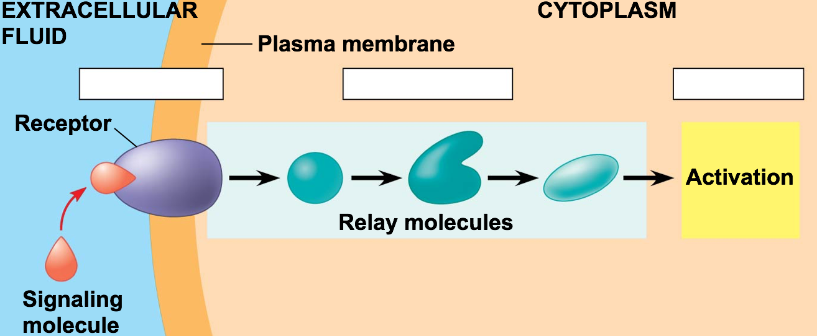
3 stages of cell
communication

Environment and Change in the _________________________________________________________________
Change ________________________________________________
Example: Epinephrine (adrenaline)
-Stress causes release from adrenal glands
-Epinephrine targets liver and muscle cells
- ______________________________________________ that breaks apart glycogen
- Glucose is released into the blood to provide energy for the body

3 major types of 1) __________________________________
Cell Membrane 2) __________________________________
Protein Receptors 3) __________________________________

G-Protein Background info: How it works:
Coupled Receptor
-Used in: embryonic development, taste smell
-Diseases can interfere in G-protein function:
Cholera, Pertussis, Botulism
-60% of medicines affect G-protein pathways
-

Ligand Gated Background info: How it works:
Ion Channel
-Used in: many diverse processes, nervous system

Tyrosine Kinase Background info: How it works:
Receptors
Involved in: metabolism, cell cycle
Linked to: Cancers, diabetes, bone disorders, inflammation

Signal Transduction Signal Transduction Pathway= ____________________ in which a molecule is modified and
Pathway activated, which modifies/activates another molecule…

Relay Molecules: ____________________________________________________________
Example: Protein Kinases- molecules that modify/activate the next molecule by
phosphorylating it

_____________________________: small molecules, such as cyclic AMP or Ca⁺, that can
be used to activate relay molecules in a pathway

Example 1: Phosphorylation Cascade

Example 2: Secondary Messengers

BIG IDEA:

A series of changes during a signal transduction pathway leads to an overall change
(usually temporary) in the cell!
I feel different…

Summary

