Semester 1 Final Review
Name: __________________
Period: _______ Seat: ______
Worth 25 Points
Scientific Method
1. Define: Control-
Variable-

2. List the steps of the scientific method in order

3. What is the difference between a hypothesis and a theory?

4. How do scientists compensate for unavoidable experimental error?

5. a. Which type of graph is best to use for showing change over time? __________________
b. Which graph is best used for comparisons? _________________

Macromolecules
- ___________ is the most common atom that is the building block of life because it can form ______ chemical bonds.

2. Where do living things get their matter (atoms/molecules/macromolecules) from?

3. a. What is the law of conservation of matter?
Matter cannot be created or destroyed, only ________________________

b. What does our body do with macromolecules?

- Complete the chart about macromolecules.
Macromolecule | Monomer | Function
Carbohydrates
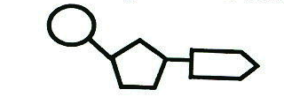
- Identify this monomer. _____________________ What are its 3 parts?

6. Where do you get your monomers from, to build your macromolecules?

Cells
1. What are the two main types of cells? _______________ and ___________________

2. What does “Pro no, Eu do” mean?
Pro no, Eu do means __________________________________________________________________
______________________________________________________________________________________.

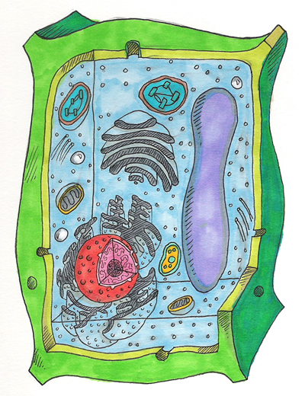
3 Which are prokaryotes and which are eukaryotes below?
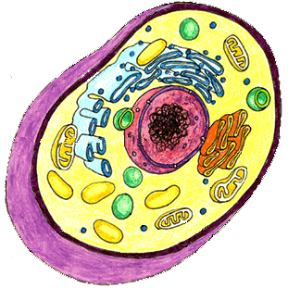
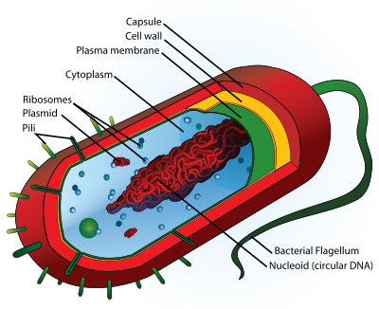

Animal Cell Bacteria Cell Plant Cell
___________ _______________ ______________
4. What 4 things do all cells have no matter which type of cell they are?
All cells have
5. Draw a picture of the cell membrane and label its parts.
Cell Membrane:

6. What does the cell membrane do?

7. a. What 3 things do plant cells have that animal cells do not?
Plant cells have

b. Why do plants have these three things but not animal cells?
Plant cells have these three things because

8. Describe what organelles are in your own words?
Organelles are__________________________________________________________________

9. What organelle contains DNA which controls the cells activities?________________
10. What organelle synthesizes proteins? ___________________
11. What is the organelle that packages and secretes proteins out of the cell? ___________________
12. What organelle in both plants and animals breaks down glucose to provide energy for the cell?
________________
13. What macromolecule is assembled, modified and secreted by the rough endoplasmic reticulum?
______________
14. What macromolecule is assembled and secreted by the smooth endoplasmic reticulum?
___________________
15. What organelle uses carbon dioxide and sunlight to synthesize sugar and store energy?
___________________
16. What structure found only in plant cells provides support and protection? ___________________
17. What is the function of the cytoskeleton?

18. What is cell differentiation and why is it important?

Cell Membrane transport
1. What are 3 types of transport? (not including endo or exocytosis)

2. What is diffusion? Do molecules move from low to high or high to low concentrations?

3. a. How is facilitated diffusion different? b. How is active transport unique?

4. What type of transport is Osmosis? Explain why you get old people fingers when you stay in the pool too long.

5. What is endocytosis? Exocytosis?

DNA and Protein synthesis
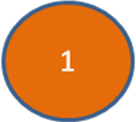
1. DNA is a set of instructions to make and maintain a living thing. It contains a secret code that is really instructions for assembling ____________________ which determine our _______________________

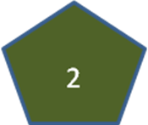
2. The monomer unit to the right which connects together to other similar units

to make DNA is called a __________________

3. Label its three parts.

4. Name the 4 bases found in DNA? 1. ____________ 2. ______________ 3. _____________ 4. ____________
5. What types of bonds hold together DNA?

6. DNA replication results in two DNA molecules
a. each with two new strands c. one with two new strands and the other with two original strands
b. each with two original strands d. each with one new strand and one original strand
7. When does DNA replication (making a copy) occur?

8. Complete the following chart on DNA and RNA:
 | DNA | RNA
Type of Sugar
Bases
Number or Strands
In what part of the cell is it found?

9. Protein synthesis can be summarized as __________ _________ __________ (3 points)

10 Fill in the blanks with the correct organelles: Protein synthesis starts in the ________________, then moves into the ____________________ and ends on a ______________________.

11. In protein synthesis DNA mRNA is called _______________
It takes place in the _______________________

12. Reading the codons in the mRNA to put together amino acids to make a protein is called ___________________.
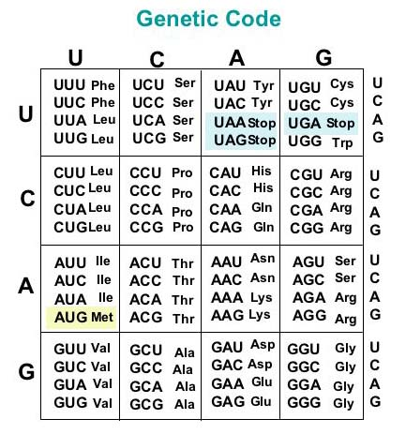
It takes place on a ______________________

13. Write the complimentary DNA strand ACCATAGATACT

14. a. Transcribe this DNA: GGACTAGAATCCATC

b. How many codons are there? ______

15. Translate this mRNA: AUGCAGAUCACCGGAUAGUAA

16. Make the protein this DNA codes for: TACCCATGATAGGACCAGATT

17. There are 20 different amino acids you can combine to make proteins. You can make different proteins by changing the ________________________ and ________________________ of the amino acids.

18. Name the two kinds of mutations and state which is worse.

19. Not all mutations change the protein. Why?

Chromosomes, Mitosis and Meiosis
1. A chromosome is made of _________________ wrapped tightly around __________________________.

2. Somatic cells = ____________________ = __________________________
Gametes = _______________________ = __________________________

3. How many chromosomes does a human gamete contain? ______
How many chromosomes does a human body (somatic) cell contain? ______

4. What two chromosomes do you need to be female? ________
What two chromosomes do you need to be male? ________
5. A fish has 94 chromosomes in its body cells. What is its haploid number? ______ What is its diploid number? ____
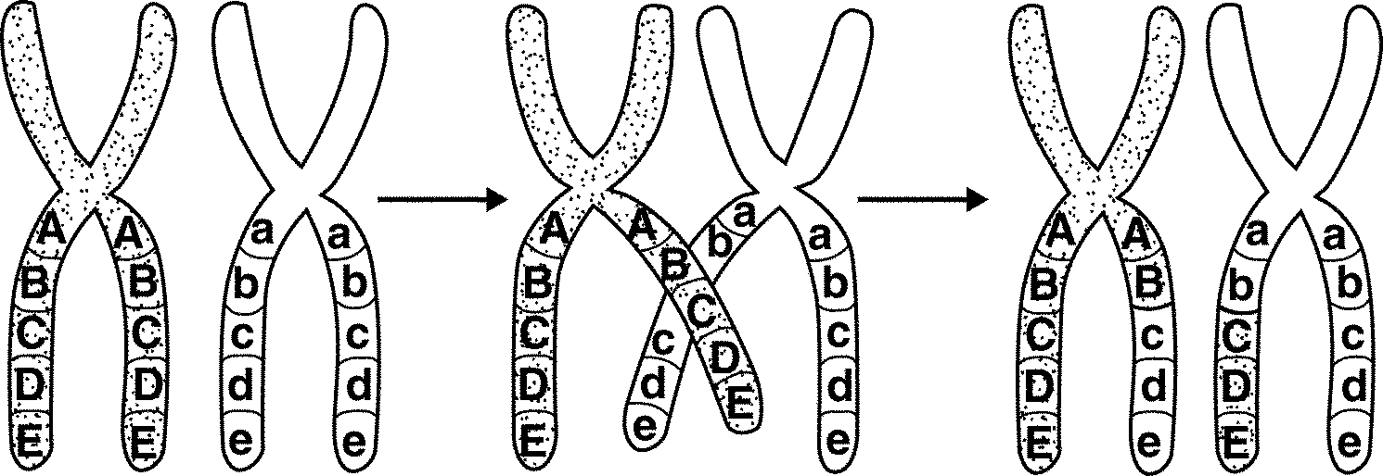
6. When does chromosome (DNA) replication occur?

7. What is crossing-over? During which phase does it occur?

8. When sperm and egg come together they form a _________

9. Math…

But first a. Put a box around the sex chromosomes and a big circle around all the autosomes

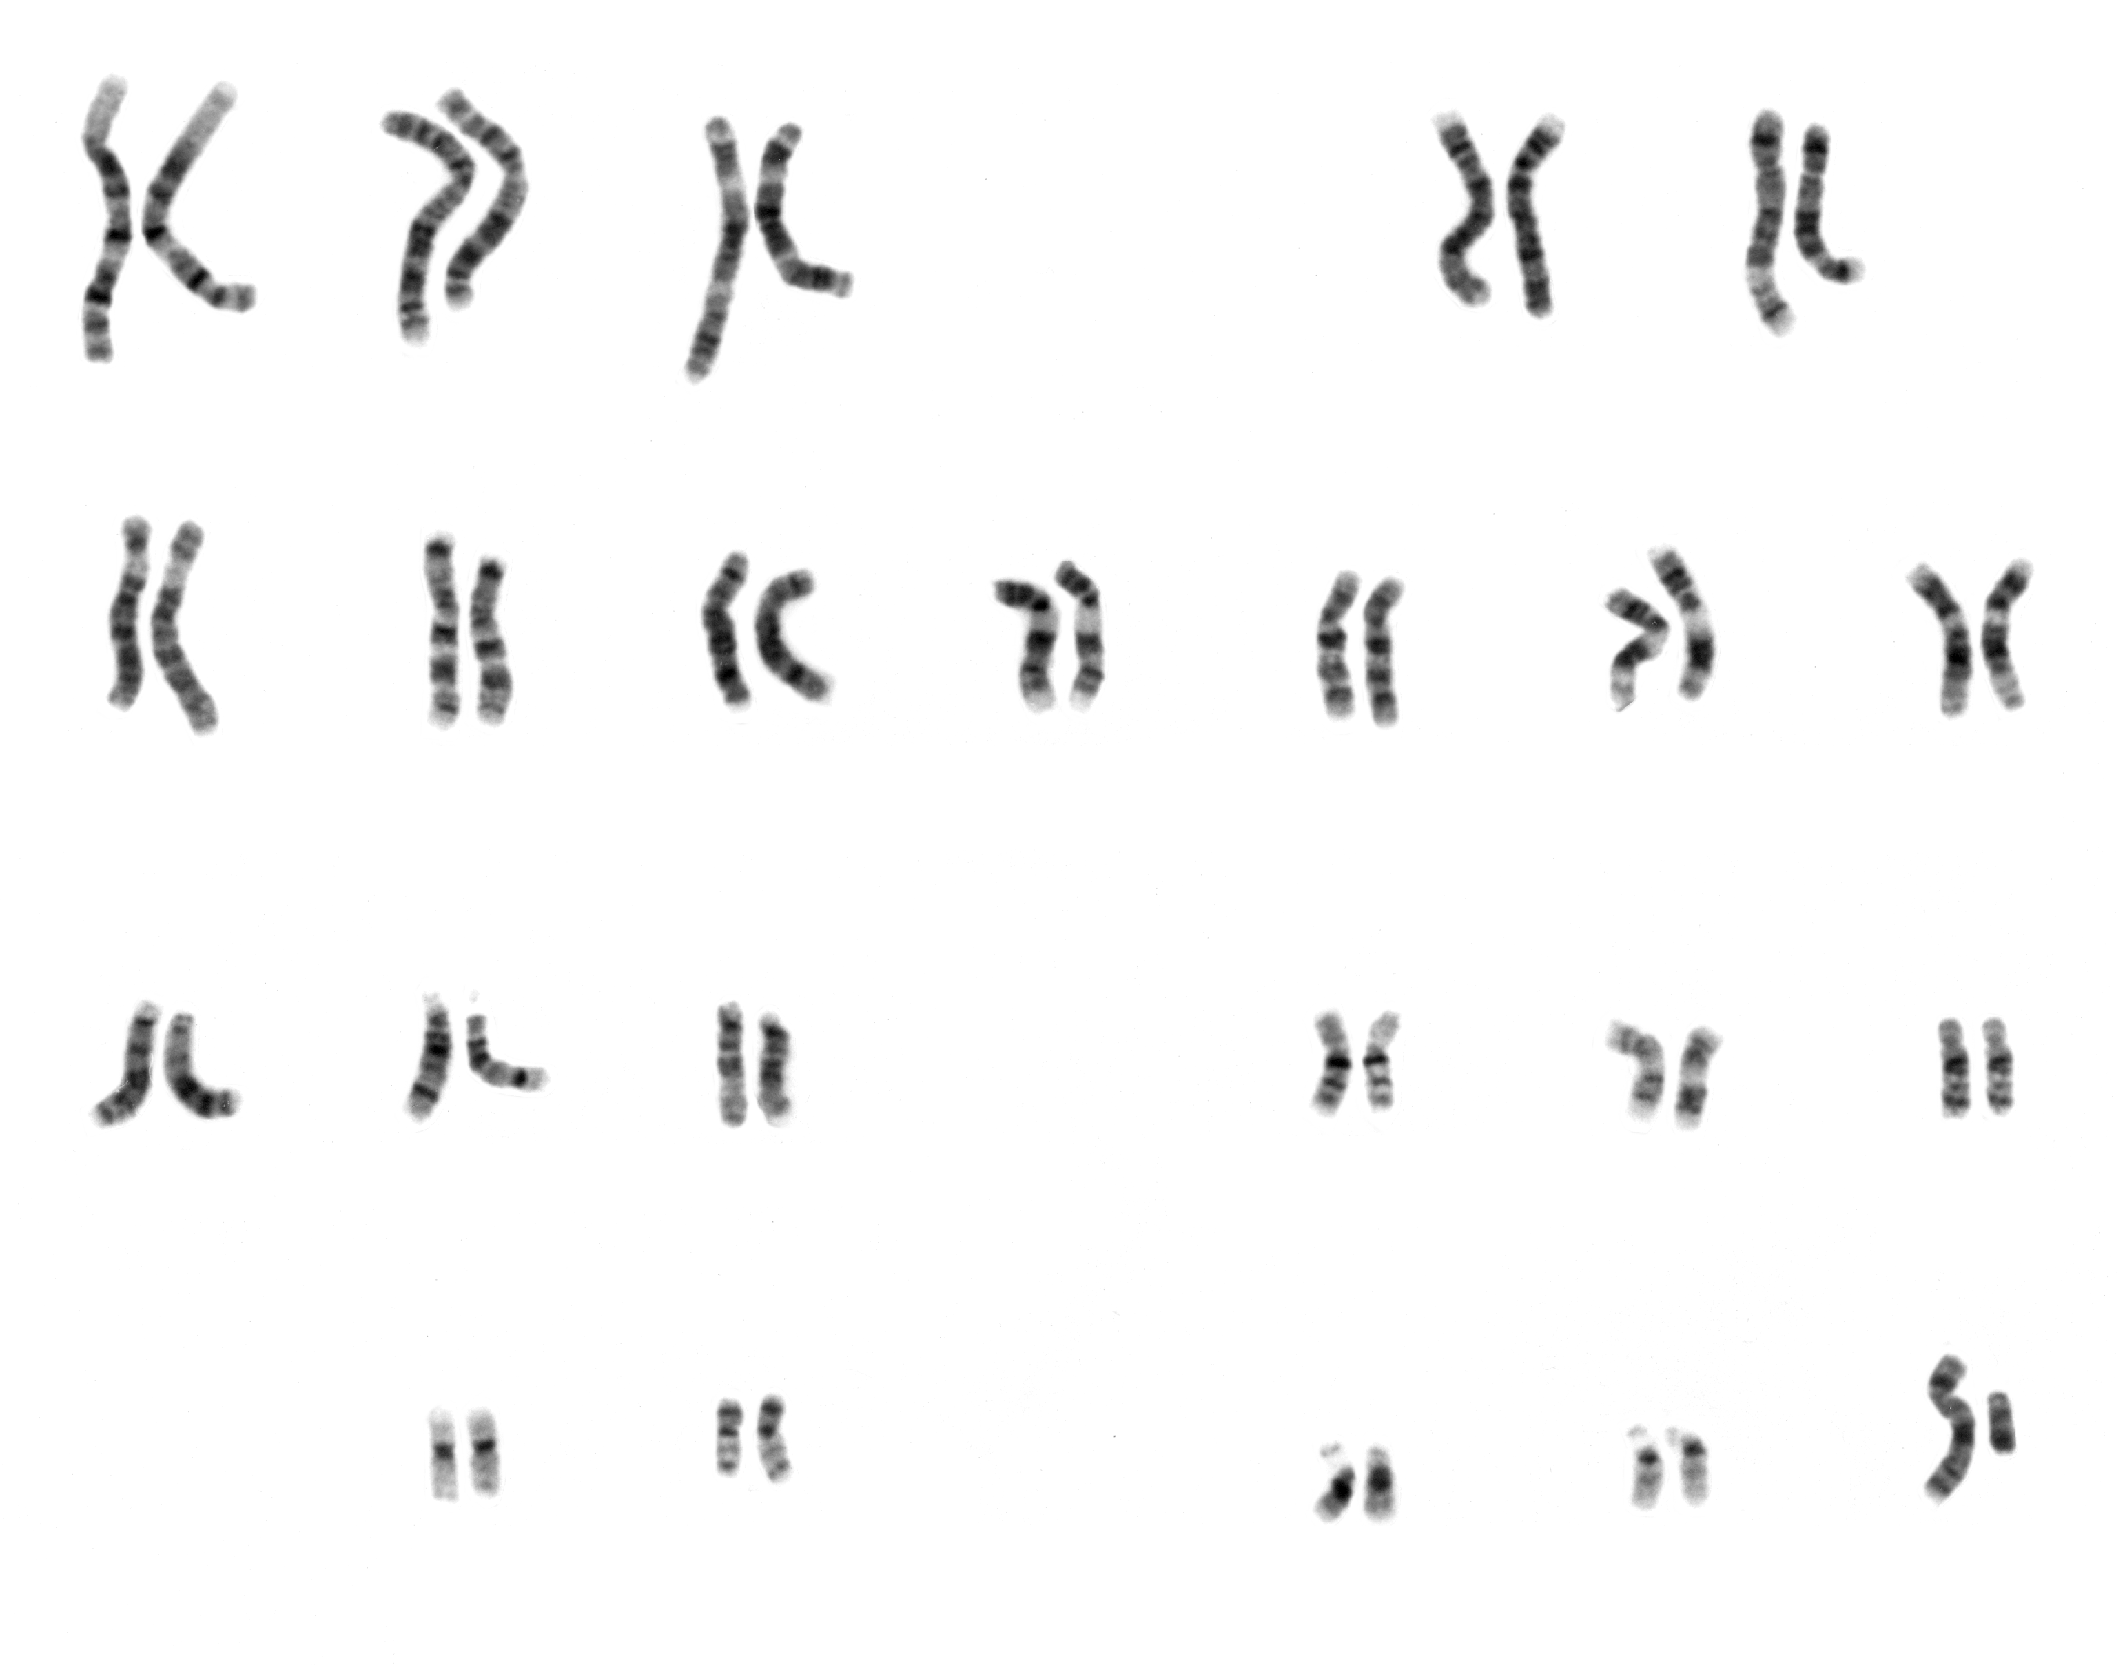

b. How many chromosomes do humans have total in each cell?

c. How many pairs?

d. How many are sex chromosomes?

e. How many are autosomes?

e. Complete the drawing using the math from b-e. Remember the numbers have to add up.

Egg Sperm
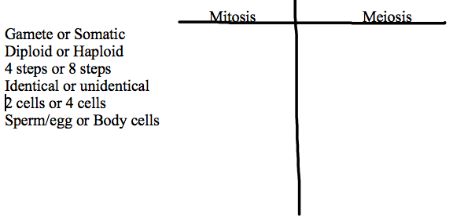

10.

Zygote
Genetics
1. What does heterozygous mean?
What does homozygous mean?
2. What is the law of segregation?

3. What is the law of independent assortment?

4. In flowers, blue flower petals are dominant to red flower petals.
What are the possible phenotypes for the following flowers with these genotypes?
BB _______________________Bb _______________________bb _______________________

5. What is the phenotype of a heterozygous person if F is freckles and f is no freckles?

6. In humans, big ears are dominant to small ears. B=________________ b=________________
What are the genotypes for a person with big ears? _____,_____
What is the genotype for a person with small ears? ______

7. In dogs, short hair (H) is dominant to long hair (h). If a heterozygous short hair dog is crossed with a long hair dog, what percentage of the offspring will have long hair?

