Surface Area to Volume Ratios

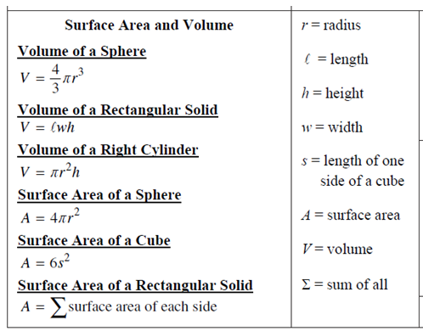

Directions: For each of the shapes below, use play-doh and make a small and large version of each shape. Using a ruler to measure your play-doh shape and the collegeboard formulas above, calculate the surface area to volume ratios.
Shape |  | Surface Area | Volume | SA/V Ratio  (divide surface area by the volume)
Sphere  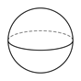 | Small
 | Large
Cube  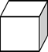 | Small
 | Large
Explain why a greater surface area to volume ratio is more efficient for delivering nutrients and eliminating wastes.

