Why are cells small? Does size matter for a cell?

Purpose: To examine how a cells surface area and volume affect its ability to exchange nutrients and waste products

Background: The cells you’ve looked at in biology have all been with the use of a microscope: they’ve all been very, very small. But some cells are not – they are much bigger, and you can even see them without any help from magnifying glasses or anything ‐ for example, a human ovum (egg cell) is the size of the period at the end of this sentence. Other gigantic cells include some nerve cells found in a giant squid (over a meter long and a millimeter thick!). But...most cells are tiny. Why?

You’ve learned about osmosis and diffusion. This is how cells get almost everything they need: nutrients, ions, water, etc, and how they get rid of wastes. Will diffusion and osmosis be enough to support just any cell?

Questions
1. Do you think large cells and small cells carry out diffusion and osmosis at the same rate? Why or why not?

2. If a cell has a high concentration of something, say, waste, that it wants to get rid of, which do you predict will be able to get rid of the waste sooner – a smaller cell or a large one? Why?

Materials:
250 mL beaker potato scalpel metric ruler
graduated cylinder dissecting tray 150 mL Lugol’s Solution forceps
Procedure:
1. Cut cubes of potato the sizes stated below, starting from biggest to smallest. (X= the length of one side of the cube). You should have 5 different sized potato cubes when you are done.
X= 2.5 cm X= 2 cm X= 1.5 cm X= 1 cm X= 0.5 cm

2. Once all of the cubes are cut, place them into a 250 mL beaker and add enough Lugol’s solution to cover them all (you should add enough to cover the top of the 2.5 cm cube)
3. Let the cubes soak in the Lugol’s Solution for about 20 minutes. While you are waiting, you can start the calculations on the following table:
Length of One side of cube (cm) | Surface Area of cube  (cm²) | Volume of Cube  (cm³) | Surface Area to Volume Ratio
X | Surface area = 6 x X² | Volume = X³ | Ratio = SA/Volume
0.5
1
1.5
2
2.5

4. When the potatoes have sat in the Lugol’ s Solution for about 20 minutes, remove them with forceps and put them on a dissecting tray. Cut each cube in half and examine the cross-section.
For each cube, measure how far into the cube the Lugol’ s solution penetrated. Record this value on the following table:
Length of Once Side of Cube (cm) | Penetration Depth of Lugol’s solution (cm)
0.5
1
1.5
2
2.5

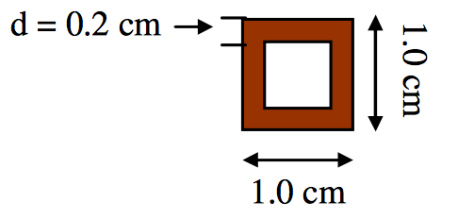
5. Make a sketch of each cross-section, showing the penetration of the Lugol’ s solution. Draw each square the actual size (using a ruler to measure). Shade in or colour the area that the stain has penetrated. Show the Depth of penetration (d) on each diagram. Eg. If the solution penetrated 0.2 cm into the cube with a length of one side(l) of 1.0 cm, the drawing would look like this:

Questions:
- Study the diagrams on the bottom of page 3. Which cube (biggest or smallest) has the greatest fraction of its total volume which is NOT penetrated by the stain? (In other words, which one has the most white space compared to brown space?)

- Which cube (biggest or smallest) has the greatest fraction of its total volume penetrated by the stain?

- If Lugol’ s solution was a nutrient and the cubes were unicellular organisms, which cube (smallest or largest) would be more able to “feed” its volume, the biggest or the smallest?

- Go to the table in Procedure 3 on page 2, to get the information to fill in the following table:
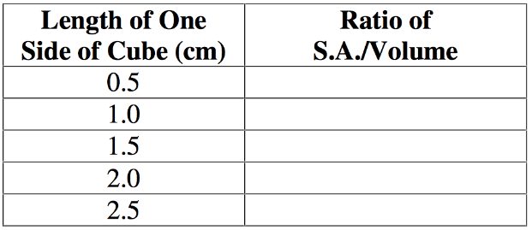
Which cube has the greatest Surface Area / Volume ratio? _________________________ Since nutrients are absorbed through the surface of the cell membrane, and nutrients are
needed by the entire volume of the cell, a (larger/smaller) ___________________________ Surface Area / Volume ratio would mean the cell has a better ability to “feed” itself.
- Which is better able to absorb enough nutrients to supply its total volume, a small cell or a large cell?
- Can unicellular organisms grow very large _____________. Explain why or why not.

