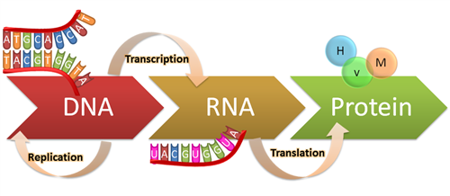**Protein Synthesis Visual Review**

**Central Dogma**

Use the image to state the central dogma of biology.

What is a gene?

What are the two steps of protein synthesis?

**Transcription**

What happens during transcription? (general)

Transcribe: TACGCCTAATCTATGATT

Explain what happens during the 3 steps of transcription. (Eukaryote)

Initiation-

Elongation-

Termination-

*How does prokaryote transcription differ?

During transcription A pairs with ____ to make the RNA.

In what direction is the mRNA made?

What enzyme is used to make the mRNA?

What will happen to the mRNA after its built?

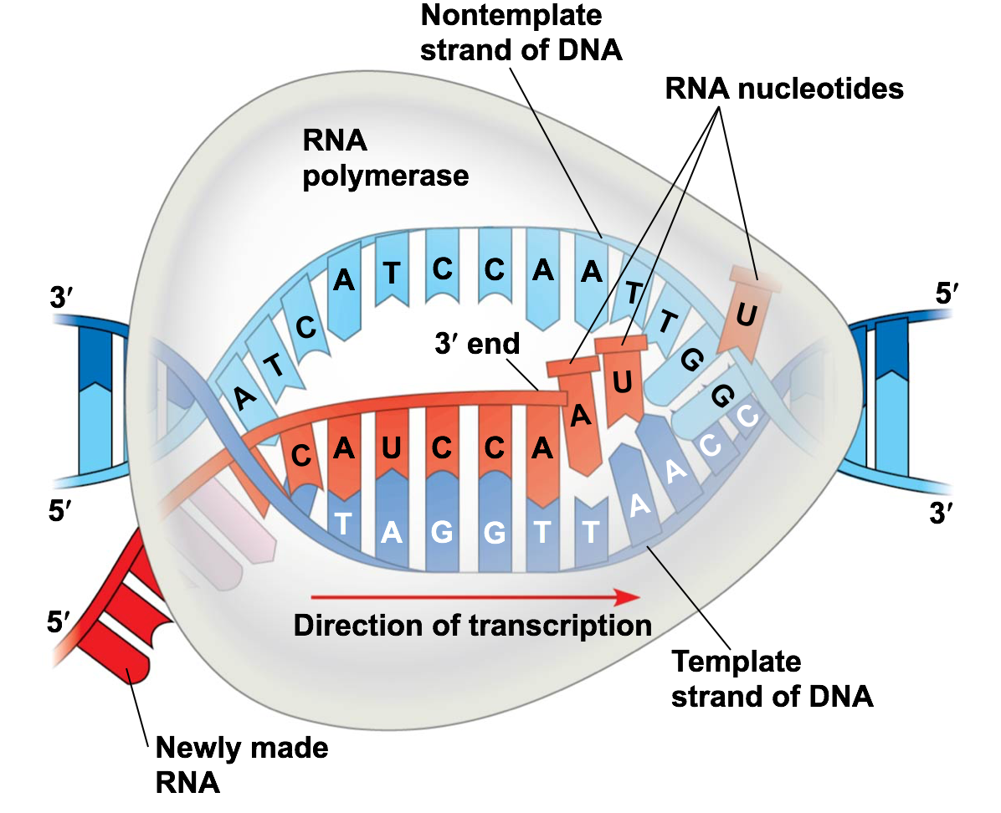

**RNA processing**

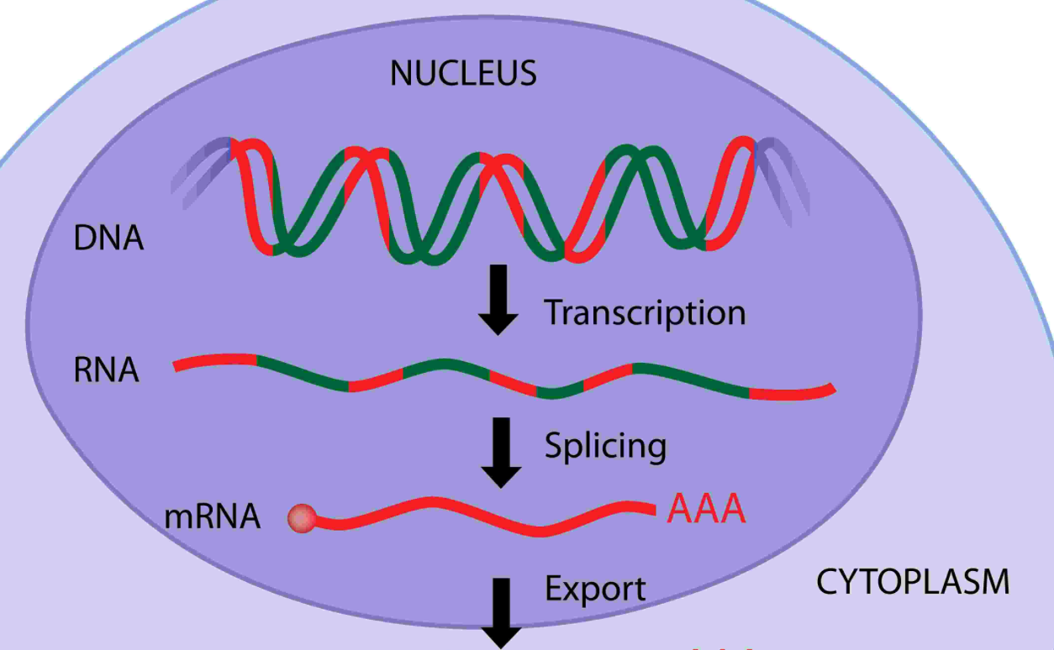

What happens during RNA processing?

In what types of cells does RNA processing occur?

Identify the introns and the exons. What happens to the introns and exons?

What is added to the 5’ and 3’ ends?

What is the role of spliceosomes?

What are 3 major differences between pre-mRNA and mature mRNA?

What is alternative splicing?

**Alternative Splicing**

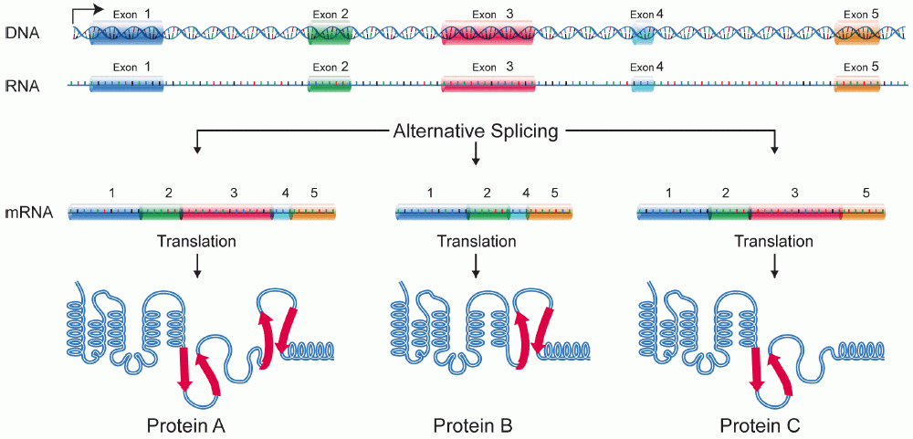

**Type of RNA**

**Ribosomes**

How many units make up a ribosome?

What is its function?

Where are ribosomes found in the cell?

What is the purpose of the E P A sites?

What usually happens to proteins made by attached ribosomes?

What usually happens to proteins made by free ribosomes?

*How do eukaryote and prokaryote ribosomes differ?

In what ways are the 3 types of RNA similar?

Describe the function of each:

mRNA-

rRNA-

tRNA-

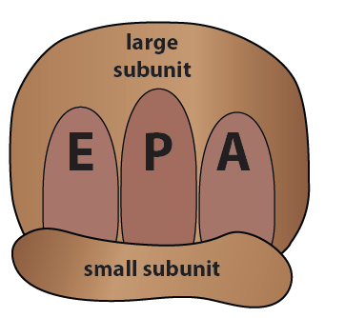

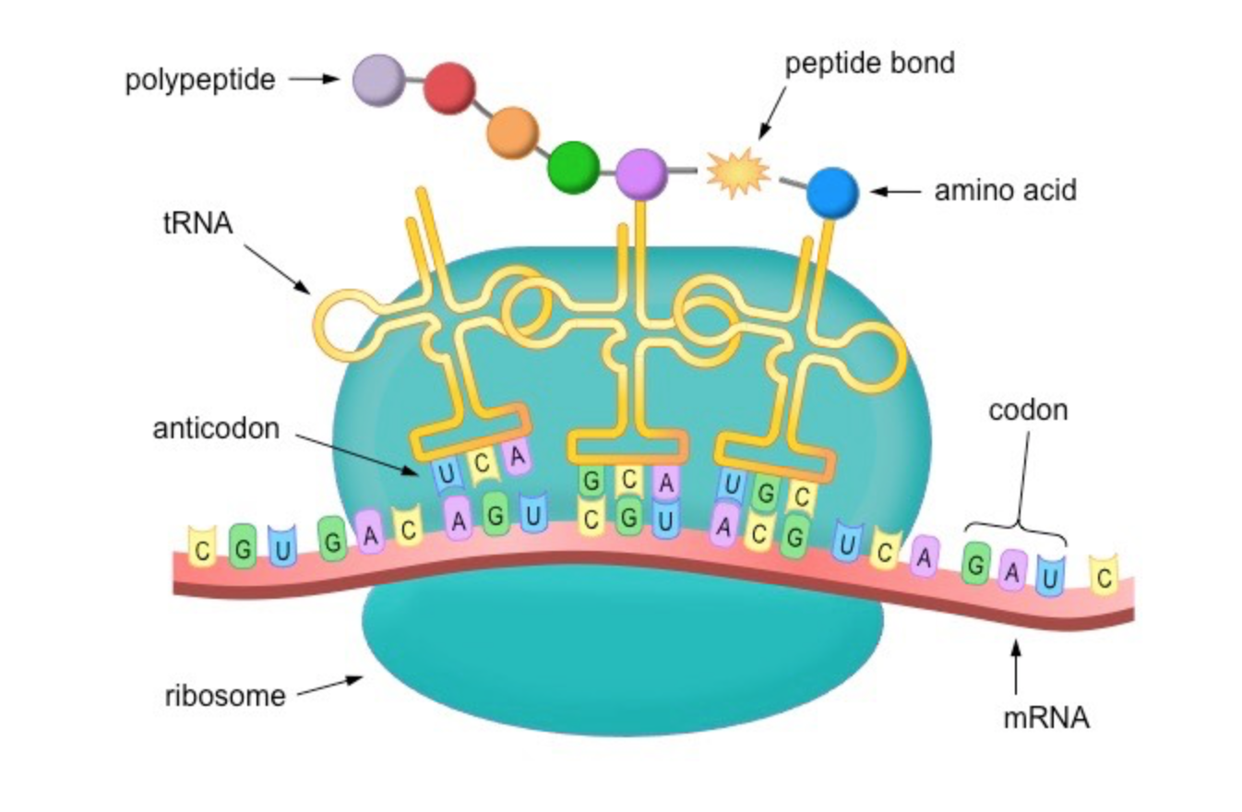

**Translation**

What happens during translation? (general)

What is a codon and where is it found?

What types of codons must be at the start of the mRNA and at the end?

What is an anticodon and where is it found?

How does a tRNA know which amino acid to drop off?

Explain what happens during the 3 steps of translation.

Initiation-

Elongation-

Termination-

What happens to a protein after it has been made?

Translate: mRNA AUGUCACGGCUGAGAGAACUUUGA

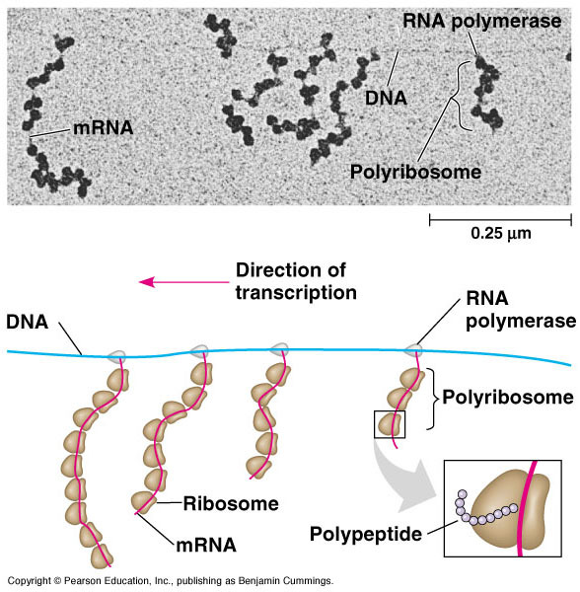

**Simultaneous Transcription and Translation**

Explain two reasons why simultaneous transcription and translation can happen in prokaryotes but not eukaryotes?

**Retroviruses and Reverse Transcription**

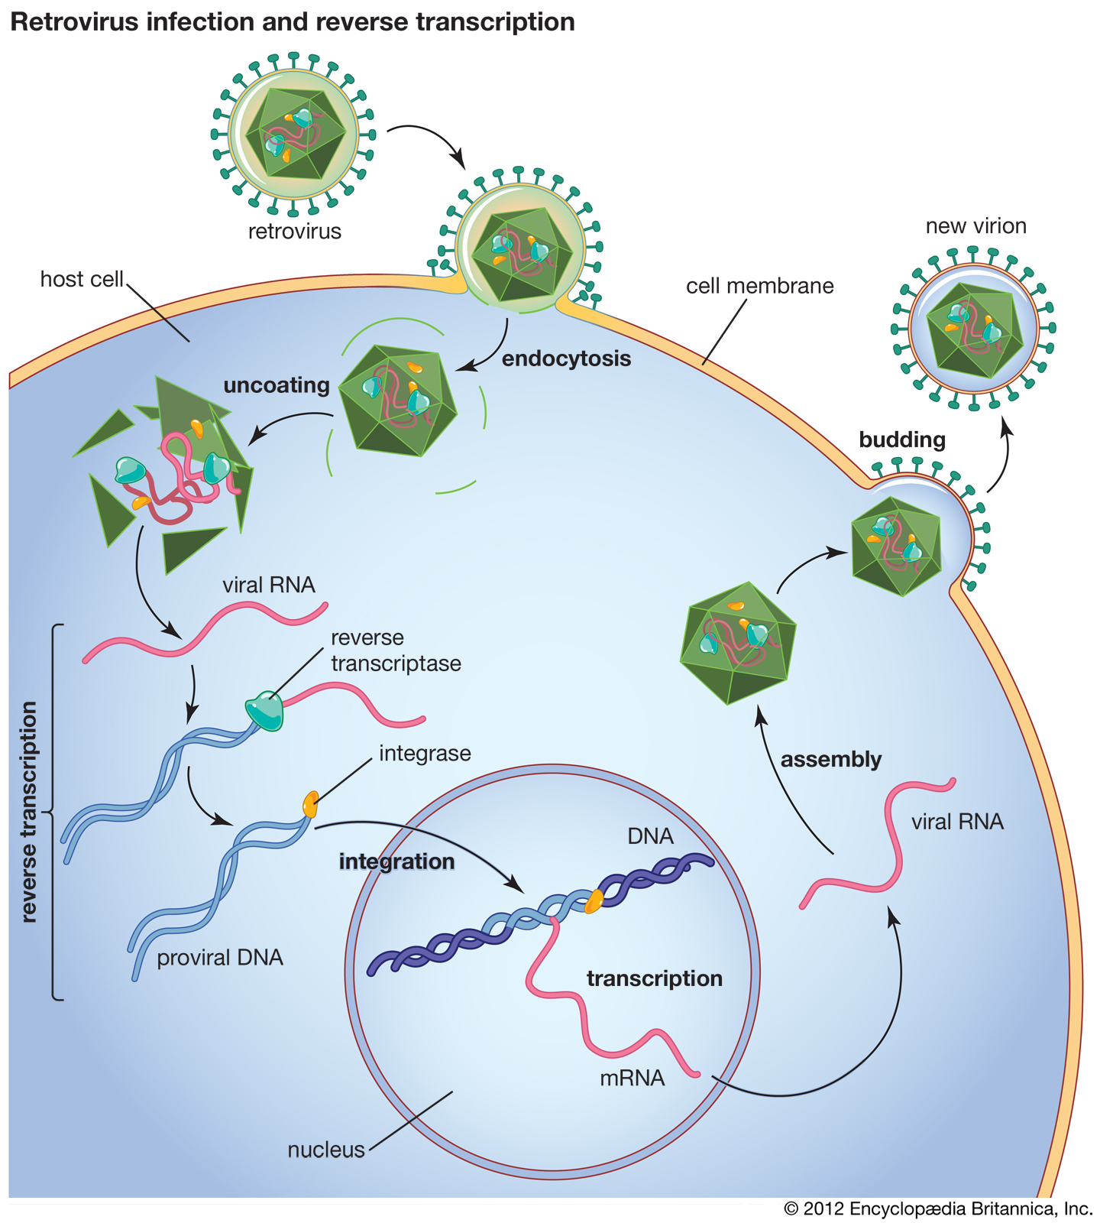

What is a retrovirus?

What is reverse transcriptase?

What is the best example of a retrovirus in humans?

What happens during reverse transcription? Include where the DNA ends up.

Write the central dogma, then write a retroviruses.

How do retroviruses go against the central dogma?

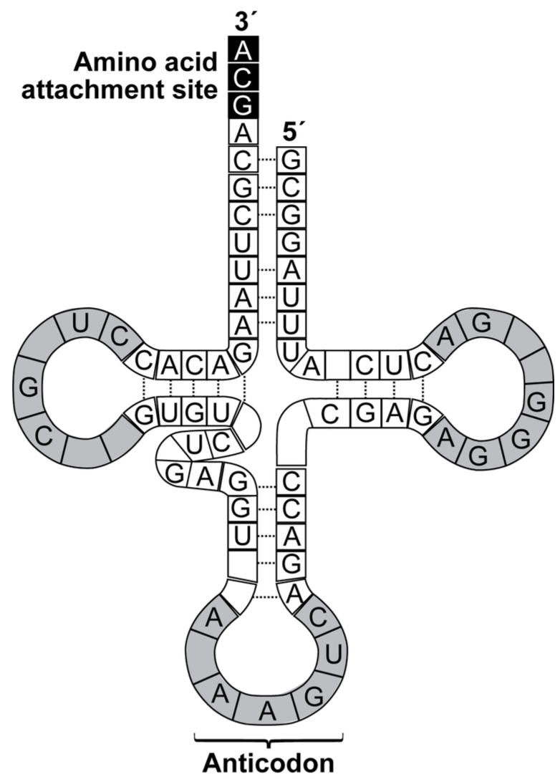

Create your own examples (hint: start with DNA and don’t forget to include a start and stop codons):

Transcribe

Translate

Transcribe and Translate

Identify the structure to the left.

What is its function?

How does it know which amino acid to drop off?

Can it carry any amino acid? Explain